

American International University-Bangladesh (AIUB)
Faculty of Science and Technology

BanglaCXR: A Two-Stage Vision-Language Pipeline for Bangla Chest X-Ray Radiology Report Generation

Md Ahasan Ullah (22-49692-3)
Md. Mehedi Hasan Shahos (22-49702-3)
Syeda Fahmida Sharmin (22-49720-3)
Estiak Rahman Ayon (22-49753-3)

A Thesis submitted for the degree of Bachelor of Science (BSc) in
Computer Science and Engineering (CSE) at
American International University Bangladesh (AIUB
Faculty of Science and Technology (FST)

Fall 2025-2026 Semester
Submission Date: 05 August, 2026

Declaration

This thesis is composed of our original work, and contains no material previously published or written by another person except where due reference has been made in the text. We have clearly stated the contribution of others to our thesis, including statistical assistance, survey design, data analysis, significant technical procedures, professional editorial advice, financial support, and any other original research work used or reported in our thesis. The content of our thesis is the result of work we have carried out since the commencement of the thesis.
We acknowledge that copyright of all material contained in this thesis resides with the copyright holder(s) of that material. Where appropriate, we have obtained copyright permission from the copyright holder to reproduce material in this thesis and have sought permission from co-authors for any jointly authored works included in the thesis.

_______________________________  Md Ahasan Ullah  22-49692-3  CSE | _______________________________  Syeda Fahmida Sharmin  22-49720-3  CSE
_______________________________  Estiak Rahman Ayon  22-49753-3  CSE | _______________________________  Md. Mehedi Hasan Shahos  22-49702-3  CSE

Approval

The thesis titled “BanglaCXR: A Two-Stage Vision-Language Pipeline for Bangla Chest X-Ray Radiology Report Generation” has been submitted to the following respected members of the board of examiners of the department of computer science in partial fulfilment of the requirements for the degree of Bachelor of Science in Computer Science and Engineering on (05-08-2026) and has been accepted as satisfactory.

Aminun Nahar  Assistant Professor & Supervisor  Department of Computer Science  American International University-Bangladesh |  |  | Nyme Ahmed  Lecturer & External  Department of Computer Science  American International University-Bangladesh
Prof. Dr. Muhammad Firoz Mridha
Professor & Head (UG)
Department of Computer Science
American International University-Bangladesh

Prof. Dr. Dip Nandi  Professor & Dean  Faculty of Science and Technology  American International University-Bangladesh |  |  | Dr. Khandaker Tabin Hasan  Professor & Associate Dean  Faculty of Science and Technology  American International University-Bangladesh

Acknowledgement

We extend our heartfelt thanks to our supervisor, Aminun Nahar, Assistant Professor of Computer Science, American International University-Bangladesh (AIUB) for her great guidance, unflagging support and constructive comments and suggestions given during the process of this research. Her knowledge and perspective were crucial to the development of direction and quality of this thesis. We also appreciate the valuable external guidance and feedback that we received from Nyme Ahmed, Lecturer, Department of Computer Science, American International University-Bangladesh (AIUB) throughout the process. The authors would like to thank the faculty members of the Department of Computer Science, American International University-Bangladesh (AIUB) for their support and academic environment for conducting this work. I would like to thank the Computer Science Department of AIUB as it was a very supportive academic environment with all the necessary resources for me to carry out my research work.

Table of Content

Declaration ii
Approval iii
Acknowledgement iv
Table of Content v
List of Figures VIII
List of Tables IX
List of Abbreviations x
Abstract xi
Keywords xii
Chapter 1 13
Introduction 13
1.1 Introduction 13
1.2 Problem Statement 13
1.3 Problem Background 14
1.4 Research Objectives 14
1.5 Research Questions 15
1.6 Motivations 15
1.7 Flow of Research 16
1.8 Significance of the Research 16
1.9 Research Contribution 17
1.10 Thesis Organization 17
1.11 Summary 18
Chapter 2 19
Literature Review 19
2.1 Introduction 19
2.2 Literature Review 19
2.3 Problem Analysis 23
2.4 Summary 27
Chapter 3 28
Proposed Model 28
3.1 Introduction 28
3.2 Feasibility Analysis 28
3.3 Requirement Analysis 29
3.4 Research Methodology 30
3.5 System Design and Architecture 31
3.6 Implementation and Simulation 33
3.7 Tools and Technologies Used 35
3.8 Summary 35
Chapter 4 37
Implementation and Testing 37
4.1 Introduction 37
4.2 System Setup and Environment 37
4.3 Implementation of the System 38
4.4 Evaluation and Testing 39
4.5 Results and Discussion 40
4.6 Summary 44
Chapter 5 46
Standards, Constraints and Milestones 46
5.1 Standards and Compliance 46
5.2 Sustainability Considerations 46
5.3 Societal Impact 47
5.4 Ethical Considerations 48
5.5 Security and Privacy Considerations 48
5.6 Design Constraints and Component Constraints 49
5.7 Data Constraints and Computational Constraints 50
5.8 Budget Constraints 50
5.9 Task Breakdown and Project Timeline 51
5.10 Milestones and Deliverables 52
5.11 Gantt Chart 52
5.12 Summary 53
Chapter 6 54
Conclusion 54
6.1 Summary of the Study / Work Done 54
6.2 Key Contributions 54
6.3 Limitations of the Study 55
6.4 Future Work 55
References 57
Appendix 60

List of Figures

Figure 1: | Methodology Diagram | 32
Figure 2: | Stage 1 System Architecture | 34
Figure 3: | Sample Image | 35
Figure 4: | Training Curve | 42
Figure 5: | Ablation Study- Anatomy Guided Projector vs FlatMLP Baseline | 46
Figure 6: | BanglaCXR Stage1- Clinical Entity F1 per Finding | 46
Figure 7: | Confusion Matrix | 46
Figure 8: | Gantt Chart | 46

List of Tables

Table 1: | Literature Comparison of Vision-Language Models for Chest X-Ray Generation | 25
Table 2: | Model Hyperparameter Table | 40
Table 3: | Training Table | 42
Table 4: | Baseline vs. Updated | 43
Table 5: | Stage-2 | 44
Table 6: | Performance Comparison of Radiology Generation Models | 44
Table 7: | Project-Thesis Deliverables | 44

List of Abbreviations

AI | Artificial Intelligence
BLEU | Bilingual Evaluation Understudy
chrF++ | Character n-gram F-score (extended)
CXR | Chest X-Ray
F1 | F1 Score
GPU | Graphics Processing Unit
IU X-ray | Indiana University Chest X-Ray Dataset
LLM | Large Language Model
LoRA | Low-Rank Adaptation
METEOR | Metric for Evaluation of Translation with Explicit ORdering
MLP | Multi-Layer Perceptron
NF4 | 4-bit NormalFloat (quantization format)
NLG | Natural Language Generation
NLLB | No Language Left Behind
NLP | Natural Language Processing
PEFT | Parameter-Efficient Fine-Tuning
ROUGE | Recall-Oriented Understudy for Gisting Evaluation
ViT | Vision Transformer
VLM | Vision-Language Model

Abstract

This is a significant problem in Bangladesh with the lack of radiologist, as many chest X-rays are not promptly interpreted by expert Radiologist. The current AI-powered radiology report generation systems such as CheXagent, MAIRA-2, and RaDialog generate reports in English, leaving out Bangla-speaking clinicians and patients. In this thesis, BanglaCXR, a vision-language pipeline method that generates chest X-ray reports in English and Bangla, is introduced. Stage 1 is a frozen RAD-DINO encoder, with a novel AnatomyGuidedProjector, that passes a LoRA fine-tuned, 4-bit quantized Phi-3.5 Mini model, utilizing 32 region queries. The stage 2 is Bangla translation of output in NLLB-200. In English, the model was trained on IU X-ray dataset (2566/550/550) on a single consumer GPU and delivered results of BLEU-1 0.2884, ROUGE-1 0.4352 and abnormality-detection F1 0.8802; while in Bangla, it was trained on the same split of the dataset and delivered chrF++ 35.18. This work introduces the first-ever Bangla medical AI NLG benchmark and a reproducible low-resource approach to multilingual medical AI.

Keywords

Radiology report generation, Vision-language model, Chest x-ray, Lora fine-tuning, Multilingual translation.

Chapter 1

Introduction

Introduction
In the last ten years, AI has gone from the periphery of academic research into the heart of healthcare systems. Previously computer vision and natural language processing were different fields of research, but with the development of vision-language models, they have now combined to understand medical images and generate meaningful, clinically relevant descriptions. One of the most common diagnostic tests globally, the interpretation of Chest X ray, has been an active field of this convergence. The potential benefits of automatic report generation for chest X-rays are that it will free up the time of overburdened radiologists, improve diagnostic turnaround times, and allow access to the expertise of specialists in locations where it might not otherwise be available. Most systems built to do this, however, only produce reports in English, which many patients and first line clinicians used around the world do not read or use in their daily work. Bangladesh is a fascinating case study in the compounding of a critical healthcare gap by this language barrier. Despite the population of around 170 million, the country has less than 700 radiologists with the bulk of them concentrated in urban centres like Dhaka and Chittagong (Adhikari et al., 2025). Chest X-rays are regularly obtained but not always interpreted and the lack of trained specialists means they can languish in district level hospitals or rural clinics for days on end. The use of AI-assisted tools, even if made accessible via telemedicine platforms, will still fail to aid English-language outputs, as those who are trained in Bangla and treat their patients without English are the ones who are affected. This research directly tackles this gap by presenting and developing BanglaCXR, a two-stage vision-language pipeline that produces English and Bangla structured chest X-ray radiology reports, which is the first system designed and evaluated for a South Asian language.

Problem Statement
While there has been significant progress in AI-based radiology report generation tools, none currently generate reports in any language other than English, failing to meet the needs of clinical practice in Bangla-speaking settings in Bangladesh. Bangladesh is among the worst hit countries in the world in terms of radiologist shortage and AI-powered diagnostics is out of reach for most of its clinicians and patients due to the lack of an automated reporting system in the local language. There is no vision-language model trained or evaluated for Bangla radiology report generation, no benchmark dataset available for assessing Bangla medical natural language generation in chest X-ray domain and no architectural components studied for generating clinical text from chest X-ray images in the South Asian language Bangla.

Problem Background
The automated generation of radiology reports has been studied for a few years, and early research was based on template-based systems and CNN-RNN encoder-decoder models. More recent approaches have focused on using large vision-language models, which are based on specialized medical image encoders and instruction-tuned language model decoders, and demonstrate meaningful performance on benchmark datasets. However, each of these systems reports in English and is tested on English-language data, mostly MIMIC-CXR and IU X-ray. The field of multilingual radiology report generation has not been studied in the literature, as shown by the two comprehensive survey papers published, Salhi and Akhloufi (2026) and Tran et al. (2026), respectively. The Bangla NLP community has also built robust baselines for general domain Bangla language understanding and generation, with recent work showing the feasibility of Instruction tuned Bangla LLMs like TigerLLM (Raihan & Zampieri, 2025). But all of these models haven't been used in medical imaging so far and the study of BenLLM-Eval (Kabir et al., 2024) has shown that even the best general LLMs are far behind the performance of English in Bangla NLP tasks, especially generation and summarization. Both gaps have never been tackled simultaneously resulting in a gap of literature that is clearly and practically impactful.

Research Objectives
The main goal of this research is to develop and test a two-stage vision-language model for producing structured chest X-ray radiology reports in both English and Bangla language with the focus for deployment in Bangladesh which is a resource-constrained region. For this, the following specific goals are targeted: to create an innovative cross-attention projector module to map visual features from a radiology specialized image encoder to region-aware embeddings for conditioning the language model; to fine-tune a parameter-efficient vision-language model using the LoRA architecture with the dataset IU X-ray; to develop a second stage translation pipeline by using NLLB-200 to translate generated English reports to clinically appropriate Bangla reports; to construct and release the first structured Bangla radiology natural language generation benchmark comprising 550 evaluated pairs of reports; to extensively evaluate the entire pipeline using established metrics for natural language generation, such as BLEU, ROUGE, METEOR, and chrF++; and to evaluate the entire pipeline in detail against F1 scores of clinical entities for twelve pathological findings.

Research Questions

Each of the above objectives is linked to the following research questions. Can a cross-attention-based anatomy-guided projector outperform a simple mean-pooling baseline on grounding language model generation in radiological visual features? Second, what can be the level of English report generation performance, measured by both NLG and clinical metrics, in the IU X-ray dataset with just a few compute shots and a parameter-efficient fine-tuned vision-language model? Third, what is the effectiveness of the translation stage in an NLLB-200 in preserving the clinical meaning of generated English radiology reports in Bangla, as assessed by character-level similarity metrics and a clinical F1 score? Fourth, what are the major mechanisms of failure of the pipeline in each pathological category and how do they differ between common and uncommon?

Motivations

This research is motivated by practical need and academic opportunity. This ratio of approximately 1 radiologist per 200,000 population, combined with the fact that most chest X-rays in district hospitals are either not evaluated or must be waited for several days before they can be discussed via telemedicine, results in the majority of patients not receiving timely consultations with a radiologist (Adhikari et al., 2025). However, this is where AI-assisted reporting can help: If the output is in a language that clinicians can use. While Bangla is the native language of more than 170 million people across Bangladesh and several hundred million in the Indian state of West Bengal and in the diaspora, it continues to under-represented in medical AI research. In addition to its clinical relevance, there is an academic gap that needs to be filled – while a number of European languages have been the subject of research in low-resource medical NLG, medical applications in South Asian languages have not been investigated at all in the field of radiology. Language accessibility has been one of the most fundamental barriers to adoption in low- and middle-income countries (LMCs) repeatedly cited in reviews of AI in global health (Hussain et al., 2025; Al-Ganad et al., 2026; Wibowo et al., 2025). This work is intended to offer not only a practical technical solution, but also an evaluative framework that future researchers with other languages of South Asia or low resource languages can follow.

Flow of Research

The research goes hand in hand with a series of six linked phases. The study starts by an in-depth literature review on vision-language models for radiology report generation, Bangla NLP, multilingual clinical NLP, and AI usage in low-resource regions that collectively form the specific gap addressed in this study. The second phase deals with the preparation of the dataset, including the collection of the Indiana University Chest X-ray dataset and filtering of valid image-report pairs to create a frontal view only dataset, and creating training, validation, and test splits. The third phase involves designing and implementing the model architecture, such as the design of the cross-attention projector based on the anatomy, the vision encoder being a RAD-DINO model, and the fine-tuning of the Phi-3.5 Mini language model decoder using LoRA. The 4th is the training of the model and running an ablation study, comparing the proposed projector with a flat-mean-pooling projector to see how much of the architecture is helpful, in an empirical way. The fifth phase involves the development of Bangla reference reports, pipeline extension to Bangla and evaluation of translation quality using NLLB-200 translation. The sixth and last step combines all the results and considers failure cases from each pathological class, covering the implications for future research and possible real-world deployment.

Significance of the Research

This research is significant on both practical and academic dimensions. On a practical level, it shows an AI system capable of producing clinically useful chest X-ray reports in Bangla can be developed and deployed on consumer-grade hardware (a 8.5 GB VRAM laptopGPU), which is available to researchers and developers in low-resource countries without access to cloud computing resources. The resulting Bangla reports create a door for district-level Bangladeshi hospitals and telemedicine providers to get an AI-assisted preliminary interpretation in their native language, thus enhancing the radiologic diagnostic support for millions of people who do not have any radiologic support currently. In terms of academic contribution, this work provides the first benchmark for Bangla radiology NLG, which will serve as a reference for future models; it proves the necessity of using cross-attention region queries in architecture over visual pooling of simple regions; and it proposes clinical entity-level F1 evaluation for medical generation systems, which can be evaluated clinically, as a practical complement to standard NLG metrics in low resource medical generation systems. The methodology and benchmark will be directly applicable to other low-resource South Asian and Southeast Asian languages for the broader research community developing medical AI and multilingual medical AI systems.

Research Contribution
This research contributes to the body of knowledge in several ways: The first and foremost contribution has been the design and realization of BanglaCXR, the first vision-language pipeline that enables end-to-end structured chest X-ray radiology reports in Bangla on 550 test cases from IU X-ray dataset. The second contribution is the novel cross-attention module, the AnatomyGuidedProjector, which maps 1370 RAD-DINO patch tokens to 32 anatomically meaningful region embeddings to condition the language model, and which is found to be architecturally essential and not just an additional layer, as the baseline MLP without it is found to degrade to a BLEU-1 score of 0.0003 compared to 0.2884 for the proposed model, upon ablation. The third contribution is the first structured Bangla radiology NLG benchmark consisting of 550 paired English and Bangla report samples along with reference translations for them, which facilitates future models to be evaluated in a reproducible way. The fourth one is a framework for the evaluation of clinical entities at the level of pathological findings, with 12 findings (such as pleural effusion, pneumothorax, cardiomegaly, consolidation) that offer a more diagnostically relevant assessment.

Thesis Organization
The rest of this thesis is structured as follows. Chapter 2 provides a thorough review of the existing literature on vision-language models for radiology report generation, Bangla and multilingual medical NLP, and parameter-efficient fine-tuning methods, culminating in a structured analysis of the gaps in the research that this work addresses. Chapter 3 presents the proposed model, covering the feasibility analysis, system requirements, the overall two-stage methodology, the system architecture including the AnatomyGuidedProjector, the LoRA training strategy, and the NLLB-200 translation pipeline. Chapter 4 discusses the implementation and testing of the system, including the environment in which development took place, the preparation of the dataset, and the evaluation results, covering quantitative NLG and clinical metrics, the ablation study comparing the proposed projector against a baseline alternative, and analysis of the generated reports. Chapter 5 addresses the standards, constraints, and project management aspects of the research, including sustainability, ethical and security considerations, data and computational limitations, and the project timeline and milestones. Chapter 6 concludes the thesis by summarizing the key contributions, acknowledging the limitations of the present study, and outlining directions for future research.

Summary

This chapter set the stage and motivation for BanglaCXR, a two-stage AI system to generate chest X-ray radiology report in both English and Bangla. The central issue – the lack of automated radiology reporting in Bangla in one nation where the number of radiologists is very low – was clearly outlined, grounded in the existing literature and linked to a series of specific, measurable research questions. The research questions direct the experimental design, the contributions clearly explain what is new in this research, and the thesis organization provides an overview of how each chapter builds towards a complete and measurable system. The next chapter explores the current research literature in depth to form the theoretical and empirical base for this research work.

Chapter 2

Literature Review

Introduction
This chapter summarizes the existing research literature that is relevant to BanglaCXR, broken down into four interrelated areas. The first is automated chest X-ray reports, in which, recent advancements in vision-language models have yielded a vast array of methods and benchmarks, establishing the current state of the art. The second is Bangla natural language processing, which has grown significantly in the last few years with dedicated pretrained models and evaluation benchmarks, but with a great lack of medical applications. The third one is multilingual and low resource clinical NLP, which offers techniques for bridging the gap between medical AI primarily developed in English and languages not well served by AI. The fourth is the use of AI in low resource healthcare environments, which sets a context for the actual limitations of BanglaCXR's use in practice. After reviewing the chapter, the chapter discusses how the four domains intersect to create the specific research gap that this thesis addresses.

Literature Review
Radiology Report Generation:
The area of automated radiology report generation has come a long way from initial CNN-RNN encoder-decoder networks to large-scale vision-language models, which comprise very large image encoders and instruction-tuned language model decoders. Salhi and Akhloufi (2026) conducted the most recent survey of this trajectory, including 51 deep learning studies from 2018 to September 2025, and also found the same dominant dataset, MIMIC-CXR, and the same clinical evaluation and multi-lingual shortcomings. Tran et al. (2026) also reviewed 14 model evaluations from 2021 to 2024, identifying the same dominant dataset, MIMIC-CXR, and the same clinical evaluation and multi-lingual shortcomings. Within the foundational architectures, CheXagent ( Chen et al., 2024) has set a benchmark design paradigm that uses an image encoder (SigLIP-Large) with a language decoder (Phi-2), connected by a two-layer MLP projector, and trained on a dataset of 8.5 million samples across 35 tasks (CheXinstruct). The clinical reader study demonstrated time savings of 81% for radiology residents when using CheXagent and established strong baselines for each view classification, VQA and report generation. A similar design approach forms the basis of SLaVA-CXR (Wu et al., 2024) which combines a CLIP ViT-L/14 encoder with Phi-2 and a three-stage Re3Training process and the RADEX synthetic dataset. SLaVA-CXR is also unique because it is designed to be deployed in a low-resource setting, with inference speeds 6.13 times faster than LLaVA-Med, which directly impacts constrained compute scenarios such as mobile devices. In terms of technical sophistication, the system reviewed by MAIRA-2 (Bannur et al., 2024) from Microsoft Research is the most sophisticated. It also adapts Vicuna-7B to the RadDINO ViT-B vision encoder with a four-layer MLP adapter and proposes grounded report generation, where each finding sentence is accompanied by spatial bounding boxes, and the RadFact evaluation framework based on logical entailment using the Llama3-70B model instead of lexical metrics. The model is trained using more than 510k examples from MIMIC-CXR, PadChest, and a private dataset from the USA, and it achieves a BLEU-4 of 23.1 and RadGraph-F1 of 34.6 on MIMIC-CXR, significantly outperforming previous work. Flamingo-CXR is the most stringent human evaluation to date, comparing 606 cases in autonomous and collaborative settings between a board-certified radiologist and an AI with 27 other board-certified radiologists in the US and India, all conducted on the same dataset, and demonstrating that in 71.2% of cases in IND1, AI-assisted collaborative reports were preferred or equivalent to human-only reports, while the results were significantly lower in the MIMIC-CXR ICU cohort. RaDialog (Pellegrini et al., 2025) is an extension of the report generation paradigm to interactive, dialogue-based clinical support. By leveraging a BERT-based alignment module and fine-tuning the Vicuna-7B with LoRA, RaDialog outperforms CheXagent with a clinical efficacy F1 score of 39.7 on MIMIC-CXR and is able to correct, summarize, and generate visual question answering for reports using a 580,000-sample instruction dataset. There is no limitation included in the model that acknowledges the non-English reporting of evaluations. The approach of XrayGPT (Thawakar et al., 2024) is simpler yet effective, with a frozen MedCLIP encoder, a single trainable linear transformation layer, and a medically fine-tuned Vicuna-7B, yielding ROUGE-1 scores of 0.3213 on MIMIC-CXR and 72% scientific accuracy in human evaluation by certified physicians on 50 test cases. GIT-CXR (Sîrbu et al., 2025) proves that end-to-end transformers, with curriculum learning based on report length, can deliver new state-of-the-art METEOR and clinical F1 scores on METEOR and IU X-ray, respectively, while ClinicalBLIP (Ji et al., 2024) demonstrates that a two-stage LoRA fine-tuning strategy and integration with prior clinical knowledge can lead to a METEOR score of 0.570 on IU X-ray, which is more than double the best competitor. Hartsock and Rasool (2024) offer a more broad architectural overview of 16 medical VLMs, discussing single-stream and dual-stream architectures, training methods (including contrastive learning and RLHF), and evaluation techniques, highlighting the key challenges of the field as hallucination, catastrophic forgetting, and the lack of clinical evaluation metrics. While the survey by Mamdouh et al. (2025) on Bioengineering provides a structured comparison of 38 papers by different methods, including transformer-based, LLM/VLM-based and graph-based methods, the authors have identified RADAR as the best-performing model for the MIMIC-CXR dataset for 2025, with BLEU-1 of 0.509 and METEOR of 0.450 respectively, and explicitly note that there is no report generation literature for non-English and low-resource languages. In this thesis, the LoRA fine-tuning strategy was directly supported by Lian et al. (2024), who showed across 13 transfer learning tasks on the NIH ChestX-ray14, CheXpert and RSNA Pneumonia datasets that LoRA significantly outperforms full fine-tuning on 13 of the 18 transfer learning tasks with a significant performance gap, especially in the low-data regime where LoRA performs at 77.1% AUROC while full fine-tuning does at 74.2% AUROC with only 1% of the dataset being labeled. The usefulness of using RAD-DINO as the vision encoder is supported by the results of MAIRA-2, where in 2024, it is the backbone of the best-performing system in MIMIC-CXR with a ROUGE-L of 0.331, and by the work of Aksoy et al. (2024), which investigates multi-modal fusion of patient demographics, vital signs and chest images with the best performance of 0.331 ROUGE-L obtained by the FullFusion model among the compared systems.
Bangla Natural Language Processing:
The advancement of Bangla NLP has been quite fast in the last 3 years, however, there is little development in the medical field. However, BanglaBERT (Bhattacharjee et al., 2022) laid the groundwork by pretraining an ELECTRA-based encoder on 27.5 GB of Bangla web text, where the researchers explicitly pointed out that the text used for pretraining does not include biomedical or clinical text. Bhattacharjee et al., 2023 built upon this by making BanglaT5 (247M parameters) based on the Bangla2B+ corpus, and creating the BanglaNLG benchmark as well as obtaining state-of-the-art results on machine translation, summarization, and question answering with an average improvement of 4% over the multilingual baselines. The authors of BenLLM-Eval (Kabir et al., 2024) give a realistic picture of the performance of the large language models (LLMs), specifically GPT-3.5, Claude-2 and LLaMA-2-13b, on Bangla in a zero-shot setting, using a set of seven tasks. The conclusion is that while the zero-shot LLMs clearly do not perform well on Bangla tasks, fine-tuned model shows improvement in tasks such as summarization with ROUGE-2 of 11.43 against 5.81 for GPT-3.5, and LLaMA-2 often outputs English rather than Bangla. In the same way, Abrar et al. (2024) show that in the health domain, with Bangla consumer health queries, even the best zero-shot model, Mixtral-8x22B, with a ROUGE-1 of 51.36, is outperformed by the fine-tuned BanglaT5 on the bigram precision metric (ROUGE-2 of 14.41 vs. 29.11). Medical entity recognition in Bangla becomes possible with high accuracy (89.58%) under the Multi-BERT Ensemble architecture with a custom annotated corpus of 6,895 medical statements, while the codeswitching between Bangla and English medical terminology and the lack of domain-specific pretrained models present the significant challenges, Bangla MedER (Aurpa et al., 2025) tells. At ACL 2025, TigerLLM (Raihan & Zampieri, 2025) has recently introduced the first properly documented family of Bangla specific (1B and 9B) LLMs that were continually pre-trained on 10M token educational corpus and fully fine-tuned on 100K instruction-response pairs, outperforming all previous Bangla LLMs by 30–55 percentage points across six benchmarks and even being better than GPT-3.5 on most tasks, but still they are entirely in general-purpose domain with no medical applications.
Multilingual and Clinical NLP:
The translation module of this pipeline builds upon a research foundation of multilingual clinical NLP that not only tackles the technical issues of medical domain machine translation (MDMT), but also the broader issue of translating medical AI into low-resource languages. Han et al. (2024) compare three multilingual models to fine-tune a translation model with only 250,000 clean bilingual sentence pairs to translate clinical texts from English to Spanish and vice versa, and find that a fine-tuned small model (Clinical-Marian) outperforms much larger models such as NLLB-distilled across most metrics and achieves the best human evaluation score (HOPE score of 0.80) score. Luo et al. (2024) provide an analysis of multilingual BERT domain-adaptive pretraining for clinical NER and HIV screening classification tasks on Dutch, Romanian, and Spanish, demonstrating that, for the tasks analyzed, the clinical domain adaptation strategy outperform the general biomedical domain by statistically significant margins, especially when the target language is similar to the domain from which the base model was trained. The L2M3 system (Gangavarapu, 2024) introduces a novel concept of combining a well-tuned Meditron-70B medical LLM with Meta's Seamless M4T v2 translation model to provide multilingual medical assistance in Telugu, Hindi, Arabic, and Swahili, reporting significant improvements in BLEU for most language pairs and pinpointing error propagation in the multi-sequence integration and cultural translation as future challenges. The most relevant multilingual experiment to us is undertaken by Salmè et al. (2025), who test the LLaVA framework using different LLM configurations for Italian, German and Spanish and baseline their results for non-English VLM-based reporting, with no testing of any language from South Asia being done.
AI for Low Resource Settings:
BanglaCXR is embedded in a set of research on challenges for medical AI in LMICs, in practice, institutions, and governance. For digital infrastructure, Al-Ganad et al. (2026) compile a scoping review of 44 studies, finding that the four key challenge domains are digital infrastructure, data quality, ethics and governance, and policy sustainability, with 81.8% of these studies stating data quality and local capacity were a barrier and 77.3% stating infrastructure limitations were a barrier. It was noted that one of the key benefits of AI is its ability to translate words from multiple languages (language translation) for multilingual populations, which has been reviewed in the context of Global South by Hussain et al. (2025); data bias was noted as a problem for AI systems trained on data from high-income countries and the use of AI in low-resource settings. Wibowo et al. (2025) interviewed 31 health professionals from seven countries in Southeast Asia, finding that lack of reliable infrastructure, paper-based records and lack of AI literacy are compounding barriers to AI implementation, especially for the context of district hospitals in Bangladesh. In a perspective paper from the AI-Sarosh workshop, Adhikari et al. (2025) specifically speak to South Asia, highlighting the need for offline-first architectures, task shifting with the assistance of AI, and locally validated models to enable equitable adoption in Bangladesh, Nepal, Pakistan and Sri Lanka, and the importance of considering gender and language equity from the outset of the data collection process.

Problem Analysis
The gap identified in the literature above is clearly substantiated and will be addressed by the study. In all the literature reviewed on automated radiology report generation, ranging from CheXagent to MAIRA-2, Flamingo-CXR, RaDialog, XrayGPT, GIT-CXR, ClinicalBLIP, and several other survey papers, there is no work that assesses report generation in any South Asian language. Although non-English evaluation is not mentioned explicitly in the limits of RaDialog, it is pointed out by the authors of the survey of Mamdouh et al. (2025) as a specific future direction, and no work has been done. This is the main deficiency. The second aspect of the issue is the evaluation infrastructure. If a researcher wanted to develop Bangla radiology report generation system, there is no benchmark for them to evaluate the system. BanglaBERT and BanglaT5 are trained from non-medical text corpus. We have seen that overall Bangla NLP performance is significantly lower than English from the results of the assessments done by BenLLM-Eval and Abrar et al. (2024) which was done specifically in the context of health. No annotated Bangla radiology dataset, no reference report set and no protocol for measuring Bangla medical NLG quality. The third dimension is the architectural challenge of effectively embedding language model generation into radiological visual characteristics under compute constraints.The third dimension is the architectural problem of using limited compute to effectively embed language model generation in radiological visual characteristics. Lian et al. (2024) have found that parameter-efficient fine-tuning is the right approach for small data sets. Rad-DINO is the best radiology vision encoder available and has been validated by MAIRA-2. But the design of the projector architecture from the vision encoder to the language model is still an open question in resource-constrained environments. The more complex the architecture, such as the four-layer MLP in MAIRA-2, the more extensive the training data must be, and simple MLP pooling which is used in XrayGPT might lose spatial visual information into a single embedding that cannot be used to guide multi-finding generation. While this method is advantageous in the medical imaging context, a novel tradeoff exists with a cross-attention mechanism based on learned region queries, similar to the BLIP-2 Q-Former network, but modified to the task of radiology with a small, fixed number of anatomy-representative tokens, which is a method that has not been tested on the IU X-ray dataset under compute constraints typical of low-resource deployment. The fourth dimension is the pipeline itself. Neither L2M3 nor Han et al. (2024) test the pipeline with medical languages, of which radiology reports are a subset, nor do both test Bangla; both show that the two-stage pipeline is practically viable for low resource languages. The clinical terms are also another challenge for the translation of Bangla as many such terms do not have Bangla equivalents and they are either transliterated or code-switched into English in clinical communication, which was observed by Aurpa et al. (2025). These factors mean that a cross-lingual evaluation of the quality of radiology reports must be carried out at the character level, and that chrF++ should be used as the primary reliability measure, rather than word-level BLEU scores. These four problem dimensions, combined with the fact that none of these hospitals has a system for generating Bangla radiology reports, the lack of evaluation infrastructure, and the unresolved question of the projector architecture of the low resource deployment of these systems, coupled with the need to keep the clinical meaning of the report from being lost during translation with a neural machine, form the research problem that this thesis addresses.
Table 1: Literature Comparison of Vision-Language Models for Chest X-Ray Generation
Paper | Model / Architecture | Dataset | Key Metric(s) / Result | Gap Addressed
CheXagent (Chen et al., 2024) | SigLIP-Large + 2-layer MLP + Phi-2 (3.1B) | CheXinstruct (8.5M samples, 35 tasks) | CheXbert-F1 / BERTScore: 0.444 / 0.488 (MIMIC-CXR findings generation) | Unified multi-task CXR foundation model; no large public CXR training corpus existed before
MAIRA-2 (Bannur et al., 2024) | RAD-DINO + 4-layer MLP + Vicuna-7B | MIMIC-CXR, PadChest, private US dataset (510K+ samples) | BLEU-4 / RadGraph-F1: 23.1 / 34.6 | Grounded report generation with spatial bounding boxes; no non-English evaluation
RaDialog (Pellegrini et al., 2025) | BioViL-T + BERT alignment + Vicuna-7B (LoRA) | 580K instruction dataset (MIMIC-CXR based) | Clinical Efficacy F1: 39.7 | Interactive, dialogue-based reporting; explicitly notes no non-English evaluation
XrayGPT (Thawakar et al., 2024) | Frozen MedCLIP + linear layer + fine-tuned Vicuna-7B | MIMIC-CXR, OpenI | ROUGE-1 / Physician accuracy: 0.3213 / 72% | Simple linear projector; lightweight design but English-only
SLaVA-CXR (Wu et al., 2024) | CLIP ViT-L/14 + Phi-2, 3-stage Re3Training | RADEX synthetic dataset | Inference speed vs LLaVA-Med: 6.13x faster, outperforms 7B models at 2.7B | Low-resource deployment efficiency; no multilingual coverage
GIT-CXR (Sîrbu et al., 2025) | End-to-end transformer, curriculum learning | MIMIC-CXR | METEOR / Clinical F1: state-of-the-art on these metrics | Curriculum learning by report length; English-only
ClinicalBLIP (Ji et al., 2024) | InstructBLIP + 2-stage LoRA + clinical knowledge prior | IU X-ray | METEOR: 0.570 | Prior clinical knowledge integration; no multilingual extension
Flamingo-CXR (Tanno et al., 2025) | Flamingo-based VLM | IND1 (India), MIMIC-CXR (606 cases) | Radiologist preference rate: 71.2% preferred/equal (IND1) | Largest human clinician evaluation to date; weaker on ICU cohort, English-only
Mamdouh et al. survey (2025) | Survey of 38 papers (transformer, LLM/VLM, graph-based) | MIMIC-CXR, IU X-ray, 10+ datasets | BLEU-1 / METEOR (top model RADAR): 0.509 / 0.450 | Comprehensive 2021-2025 survey; explicitly notes absence of low-resource language RRG
Salhi & Akhloufi survey (2026) | Survey of 51 DL studies (2018-2025) | MIMIC-CXR-centric | N/A (survey) | Most recent comprehensive RRG survey; confirms multilingual RRG remains unexplored
Beyond Images (Aksoy et al., 2024) | EfficientNetB0 + cross-attention + Transformer decoder | MIMIC-CXR + MIMIC-IV + MIMIC-IV-ED (3,000 linked samples) | ROUGE-L (FullFusion): 0.331 | Multi-modal fusion of clinical metadata with images; single institution, small dataset
BanglaBERT (Bhattacharjee et al., 2022) | ELECTRA-based encoder, 110M params | Bangla2B+ (27.5GB, 2.18B tokens) | BLUB score: 77.09 | First large-scale Bangla pretrained LM; no biomedical/clinical text, encoder-only
BanglaT5 / BanglaNLG (Bhattacharjee et al., 2023) | T5-based seq2seq, 247M params | Bangla2B+, 6 NLG tasks | Avg. gain over mT5: +4% | First Bangla NLG benchmark; no medical domain tasks
BenLLM-Eval (Kabir et al., 2024) | Zero-shot eval: GPT-3.5, Claude-2, LLaMA-2-13b | XL-Sum, SQuAD_Bangla, BNLI, etc. (8 datasets) | ROUGE-2 (summarization): 5.81 (GPT-3.5) vs 11.43 (fine-tuned mT5) | First systematic LLM evaluation on Bengali; confirms zero-shot LLMs underperform fine-tuned models
Bangla MedER (Aurpa et al., 2025) | Multi-BERT Ensemble (dual parallel BERT) | Custom Bangla medical corpus (6,895 statements) | Accuracy / Macro-F1: 89.58% / 86.55% | First Bangla medical entity recognition system; small dataset, no biomedical pretrained Bangla model
TigerLLM (Raihan & Zampieri, 2025) | Continual pretrained + fine-tuned Bangla LLM (1B/9B) | 10M token educational corpus, 100K instruction pairs | Improvement over prior Bangla LLMs: +30 to +55 pts across 6 benchmarks | First documented Bangla-specific LLM family; general-purpose only, no medical domain
Han et al. (2024) | Clinical-Marian vs. NLLB-distilled vs. mBART | ClinSpEn-2022 (EN-ES clinical translation) | HOPE human eval score: 0.80 (Clinical-Marian) | Demonstrates small fine-tuned models can beat larger general translation models on clinical text
L2M3 (Gangavarapu, 2024) | Meditron-70B + Seamless M4T v2 | Multilingual medical QA (Telugu, Hindi, Arabic, Swahili) | BLEU improvement: substantial gains, language-dependent | Multilingual medical LLM + translation pipeline; no Bangla, no radiology
Salme et al. (2025) | LLaVA framework, multiple LLM backbones | Radiology reports (Italian, German, Spanish) | Baseline established (N/A) | First multilingual VLM-based radiology reporting baselines; no South Asian language
Lian et al. (2024) | LoRA vs. full fine-tuning on radiology-pretrained ViTs | NIH ChestX-ray14, CheXpert, RSNA Pneumonia | AUROC (1% labeled data): 77.1% (LoRA) vs 74.2% (full FT) | Validates LoRA as superior in low-data regimes; supports BanglaCXR's fine-tuning choice
Adhikari et al. (2025) | Perspective paper (AI-Sarosh workshop) | N/A (qualitative) | N/A | Identifies offline-first design and language equity as preconditions for South Asian AI health adoption

Summary
There is a well-documented gap in the literature for the development of a radiology report generation system in Bangla language, a benchmark for evaluating it, and the architectural and translation aspects needed for building such a system together have never been studied. Only the best available systems, namely CheXagent, MAIRA-2, RaDialog and Flamingo-CXR, offer validated design choices such as using RAD-DINO as the vision encoder, LoRA to fine-tune them, and NLLB-200 as the translation backbone that are absent in Bangla as well as missing the cross-attention projector architecture under the compute constraints of a consumer laptop-based GPU. Together, these articles in the literature confirm that the problem is technically achievable and clinically relevant. The proposed BanglaCXR system is explained in the next chapter in detail starting from feasibility, architecture design to implementation.

Chapter 3

Proposed Model

Introduction
The chapter is a comprehensive technical description of BanglaCXR system. After the feasibility analysis to determine if the approach is feasible in the resource limitations of this research, the chapter progresses through the functional and non-functional requirements of the system, the two-phase research process from vision to English text and English to Bangla, the full system architecture, and implementation and training decisions to create a final model. The main architectural challenge discussed here is how to develop a clinically viable, language-specific radiology report generation pipeline, on top of an open source set of model components, a publicly accessible but still reasonably sized dataset, and a consumer-grade GPU, without simultaneously making a novel, verifiable architectural contribution.

Feasibility Analysis
In a technical sense, the proposed system is technically achievable, with the available resources. The entire pipeline is developed for NVIDIA GeForce RTX 5050 Laptop GPU with 8GB VRAM, which is a limitation that prevents large models from being trained from scratch, but can support the fine-tuning of large models up to 4 billion parameters using 4-bit quantized models. The main training resource, the IU X-ray dataset, consists of 7,470 chest X-ray images, accompanied by radiology reports, and is publicly available in Open-i.The IU X-ray dataset is the primary training resource which contains 7,470 chest X-ray images with associated radiology reports, adequate to fine-tune a vision-language model for supervised learning. The weights for all the model components, RAD-DINO, Phi-3.5 Mini, and NLLB-200 are provided as open source pretrained weights and do not need commercial licenses from HuggingFace. The training infrastructure was developed in Python and is based on PyTorch, Transformers and PEFT, and is mature, documented and works directly on Windows machines. The training time is of the order of a few hours on the target hardware and was completed in ~25 epochs, demonstrating that training time is consistent with a thesis research program. The research is economically feasible with the use of free and open resources. No API usage, cloud compute credits or proprietary data licenses are required. By leveraging LoRA and 4-bit quantization specifically, it reduces VRAM demand to the point of being possible to run on commodity hardware as demonstrated by Lian et al. (2024) and shown to be effective by other researchers at institutions in Bangladesh and other low-resource environments, avoiding the need for dedicated compute facilities. From an operational perspective, the two-stage pipeline enables each of the stages to be modularly developed, tested and evaluated to minimize risk in implementation. The English output from Stage 1 is also available to use as a backup in case the translation quality of a report is not good enough for Stage 2. The system does not need internet connectivity at inference time, thus it can be deployed in the offline-first setting which is made essential by Adhikari et al. (2025) in Bangladesh's district hospital context.

Requirement Analysis
The requirements of BanglaCXR are as follows: The system should be able to receive as an input an x-ray of the chest in a regular image format and generate as output an x-ray structured report (Findings and Impression sections). It should be able to create this report in both English and Bangla, with the Bangla report maintaining the clinical content of the English report. The system should identify 12 specific pathological findings such as Pleural effusion, Pneumothorax, Cardiomegaly, Consolidation, Atelectasis, Edema, Lung opacity, Nodule or Mass, Fracture, Hyperinflation, Degenerative changes and Normal chest appearance and then accurately convey them into the written text. For English output: BLEU-1, BLEU-2, BLEU-4, ROUGE-1, ROUGE-2, ROUGE-L, METEOR, and chrF++. For Bangla output: BLEU-1, BLEU-4, and chrF++. For each of the twelve clinical categories, precision, recall, and F1 scores should be computed per label. There are also the non-functional requirements that are important in this deployment context. All of the training pipeline has to be contained in 8.5 GB of VRAM. The time required to have the inferences completed should not exceed the time of reading the image and should not exceed 30 seconds per report in the same hardware. The system should not have to be connected to the Internet during inference. It is recommended that the code base is written in reproducible Jupyter notebooks allowing to rerun the entire pipeline from scratch. The report should be generated in the same prompt template as in training (Findings followed by Impression), and be written in English. The output of the translation should be in Bangla script using Unicode characters, which can be checked by looking through it, without requiring any special medical expertise.

Research Methodology

BanglaCXR is a two-stage process that breaks down the problem of generating multilingual radiology reports into two manageable parts which are rooted in well-documented solutions from the literature. In the first step, a vision-language model is trained to produce structured radiology reports from chest X-ray images, while using natural language to describe the image content.The first step is to train a vision-language model that produces a structured radiology report from the chest X-ray image while using natural language to describe the image content. The second step is the use of a pretrained multilingual neural machine translation system to translate English reports into Bangla. This approach of two stages is preferred over an end-to-end Bangla generation for three reasons. First, the amount of English chest X-ray training data is significantly larger and more varied than any Bangla-specific training data and, by separating the vision-to-language step from the translation step, it can both be optimized using the data best suited to it. Second, English production in stage 1 can be directly assessed against a set of standards and it is easy to ensure that the vision-language model is functioning properly before assessing the translation phase. Third, the modular architecture allows for the upgrading of the translation stage independently, as the translation model for Bangla is improved, without retraining the vision-language core. The method is similar to the one used by Han et al. (2024) and Gangavarapu (2024), who showed the competitive performance of two-stage multilingual medical pipelines with direct multilingual generation, especially in low-resource environments. The methodology combines three well-established choices that are utilized in the MAIRA-2 system: RAD-DINO as the vision encoder, which has been medically pretrained on about 1.4 million chest X-ray images and is shown to be the best choice as the backbone for a vision model; Phi-3.5 Mini as the language model decoder, a 3.8 billion parameter model that demonstrates outstanding instruction-following performance as well as being smaller and able to be fine-tuned in 4-bit quantized form with only 8 GB VRAM; and LoRA with rank 32, as shown by Lian et al. (2024) to be superior to full fine-tuning in almost all experimental trials when fine-tuning medically pretrained vision models.

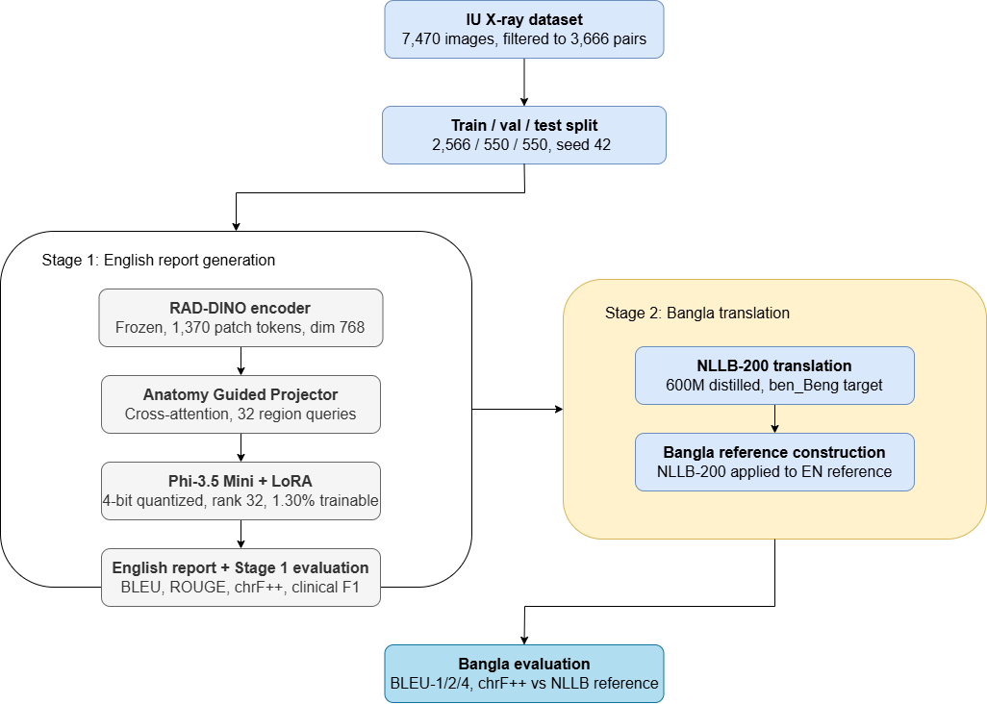

Figure 1: Methodology Diagram

System Design and Architecture
Overall Architecture:
The BanglaCXR pipeline is made up of three components: a frozen vision encoder, a trainable anatomy-guided projector, and a language model decoder fine-tuned with LoRA. The vision encoder is the pretrained Vision Transformer (ViT-Base) trained with self-supervised learning on a large image collection comprising chest radiographs (ViT-XCT), which is called RAD-DINO (microsoft/rad-dino). It takes in 518 × 518 image data and outputs a series of 1370 patch-level feature vectors, each with a size of 768. All the weights of the encoder are fixed during the training and inference process, which means that all the computing resources are allocated to the projector and the language model. The novel cross-attention module is named AnatomyGuidedProjector because it maps a 1,370-length sequence of visual patch tokens to 32 region embeddings of dimension 3,072 that can be directly concatenated to the language model input embeddings. It contains 32 learnable 768-dimensional query vectors, randomly initialized and updated during training, which are used as queries; a multi-head cross-attention layer with 8 attention heads, and the output of RAD-DINO patch is used as keys and values; a two-layer projection network with GELU activation, dropout, 768-dimensional output, and 3,072-dimensional LLM hidden space; a final layer normalization. These 32 queries aim to narrow the focus of the language model when training it, thereby making it a small representation of the different anatomical regions in the chest, namely lung fields, cardiac silhouette, and mediastinum, which enables it to attend to the different kinds of visual information in space rather than focus on a single averaged global embedding. The language model decoder is Phi-3.5 Mini (microsoft/Phi-3.5-mini-instruct), a 3.8 billion parameter transformer decoder pretrained by Microsoft that possesses good instruction following abilities. It's loaded in 4-bit NF4 quantization with BitsAndBytes, so it's available in just about 3 GB of memory. The attention projection layers (qkv_proj) and feed-forward layers (gate_up_proj, down_proj) are both equipped with LoRA adapters with a rank of 32 and scaling of 64, introducing about 50 million trainable parameters in addition to the quantized base weights, which are kept fixed during training. The total number of trainable parameters in the combined model (frozen RAD-DINO, trainable projector, LoRA modified Phi-3.5) is about 2.99% of the total number of parameters of the full model. At inference time, the pipeline takes an X-ray image and outputs the patch sequence of length 1,370 from the RAD-DINO, feeds it into the AnatomyGuidedProjector to obtain 32 region embeddings, puts them at the start of the prompt embeddings following the Phi-3 chat template format, and autoregressively generates the report using KV-cache based decoding with a repetition penalty. Stage 2: Bangla Translation The second stage translates the English reports generated in the first stage into Bangla using NLLB-200 (facebook/nllb-200-distilled-600M) which is a model trained by Meta to translate from more than 200 languages. NLLB-200 is loaded in float16 precision, using about 1.23GB of VRAM and functions separately from Stage 1. The Bangla target language token identifier (ben_Beng, token ID 256026) is specified at inference time to direct the translation. This study does not perform any fine tuning of NLLB-200; it is used as a pretrained model, similar to the baseline use studied in Han et al (2024) and Gangavarapu (2024). The Bangla reference reports for evaluation are generated using the same NLLB-200 model by translating the IU X-ray English reference reports, so that only Stage 2 is evaluated by measuring the similarity of the generated translation to the English reference reports which are generated through the same model, and thus provide a consistent reference for the evaluation.

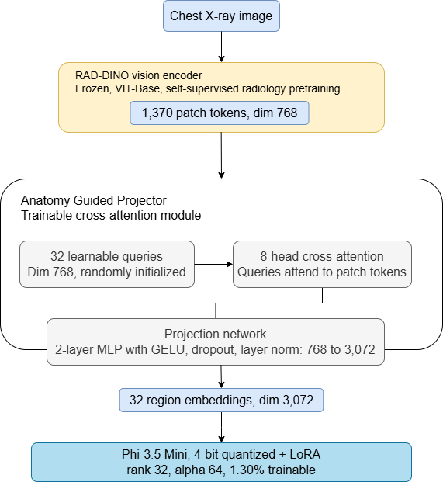

Figure 2: Stage 1 System Architecture

Implementation and Simulation
Prior to being fed into the model, both image and report are subjected to a series of concrete pre-processing steps, which are applied uniformly to the training, validation and test sets, unless otherwise indicated.
Report text preprocessing: Indiana_reports.csv contains the raw IU X-ray reports. Such type rows where the findings field or the impression field are empty, are removed without being processed, because there is no clinical text to be learned. The other rows without values in one or the other part of the report are not dropped, but filled with an empty string. The two fields are then combined into a single structured string (Findings: {findings}\nImpression: {impression}) and this is the target text the model is trained to learn. Short reports after this concatenation are ignored, which eliminates near empty or uninformative reports that would otherwise be used to train the model to return trivial short reports. It is important to note explicitly that no further text normalisation is applied at this stage, such that the placeholders used by the creators of the dataset to mask identifying information, as given in the IU X-ray reports as XXXX, remain unchanged in the text, and no lowercasing, punctuation cleanup, or medical abbreviation expansion is performed on the text.

Filtering by images and projections: The projections column of the projections file is used to select only the rows containing a "frontal" view, as the reports used in this study are mostly associated to the frontal chest X-ray (i.e. projections column = "frontal"). Entries with duplicate uid's are removed from both the projections and the merged set of data to eliminate the same patient record from the dataset more than once. The filtered projections and the cleaned report are merged on uid, and those rows that do not have an image file that exists in the image directory then are deleted. This filtering sequence is responsible for the fact that 7,470 images and 3,955 reports were reduced to 3,666 images and reports that are valid and complete enough to use for splitting.

Transform and augment images: All images are resized to image dimensions of 518 × 518 pixels that are required for input to RAD-DINO. To perform training splitting three augmentation operations are applied prior to normalization: (i) random horizontal flipping with a probability of 0.3, (ii) random rotation up to 5 degrees, and (iii) brightness and contrast jittering, with 0.2 for each. These are intentionally mild changes, which are selected for introducing some variation without altering clinically important landmarks like the position of the heart or symmetry of the lung fields. The validation and test sets are not augmented, only resized, so that the evaluation is always done on the same, unmodified images. The three splits (after augmentation) are transformed to tensors and then normalized for each channel with the standard ImageNet mean [0.485, 0.456, 0.406] and the standard ImageNet deviation [0.229, 0.224, 0.225] per channel.

Dataset splitting: Following this, the 3,666 valid pairs are broken down with a fixed random number seed of 42, making the results reproducible. The split is done in two stages, a 70/30 split of the training and combined validation and test sets, followed by a 50/50 split of the combined validation and test sets into 550 validation and 550 test sets, which are referred to throughout this thesis.

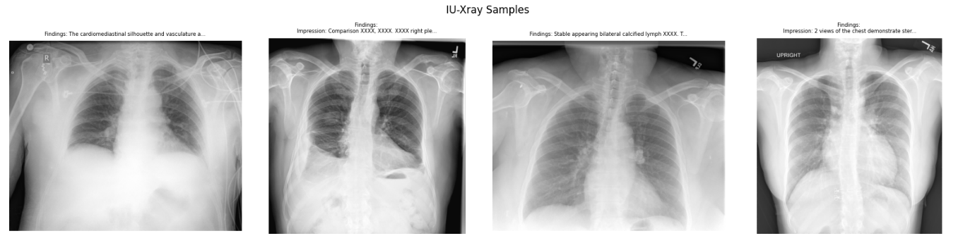

Figure 3: Sample Image

Training:

The AdamW optimizer is used with 2 sets of parameters, with the learning rate for the projector being 3 × 10⁻⁴ and the LoRA layers being 1 × 10⁻⁵, while both groups use weight decay of 0.01. A cosine learning rate schedule with linear warmup over 5% of total steps (320 warmup steps out of 6,415 total) is applied to both groups. The effective batch size is 16 (physical batch size of 2 x 8 gradient accumulations). Gradient norms are clamped at 1.0 to ensure the stability of the training. In order to tackle class imbalance between normal and abnormal cases in IU X-ray, training weight 3.0 is given to the samples whose reports contain abnormal terms, such as consolidation, effusion, pneumothorax, cardiomegaly, atelectasis, and opacity, while its weight is set to 1.0 for the normal ones. This upsampling of abnormals helps the model not be biased towards producing a generic normal finding. For this, training runs for 40 epochs, using a patience of 8 epochs and early stopping based on the validation loss. The best model checkpoint is saved when the validation loss gets better.

Table 2: Model Hyperparameter Table
Hyperparameter | Value
Optimizer | AdamW
Learning rate (projector) | 3e-4
Learning rate (LoRA) | 1e-5
Weight decay | 0.01
LR schedule | Cosine with warmup
Warmup ratio | 0.05 (320 warmup steps)
Batch size (physical) | 2
Gradient accumulation steps | 8
Gradient clipping (max norm) | 1.0
Max epochs | 40
Early stopping patience | 8 epochs
LoRA rank (r) | 32
LoRA alpha | 64
LoRA dropout | 0.05
Quantization | 4-bit NF4, double quant
Compute dtype | bfloat16
Image input size | 518 x 518 px
Random seed | 42
Max new tokens (generation) | 200
Repetition penalty (generation) | 1.3
Weighted sampler abnormal weight | 3.0 (vs 1.0 normal)

Generation:

The KV-cache mechanism is used at inference to autoregressively generate reports with full contextual coherence. The generation function pre-generates the embeddings of the visual region, along with prompt tokens, and stores the key-value states, after which it decodes new tokens, applying a repetition penalty of 1.3 to all previously generated tokens to avoid degenerate loops. The generation will be stopped at the EOS token or up to 200 new tokens.

Evaluation Implementation:

The evaluation for Stage 1 English is done using: corpus_bleu from NLTK (BLEU-1, BLEU-2, BLEU-4), rouge_scorer from the rouge_score library (ROUGE-1, ROUGE-2, ROUGE-L), meteor_score from NLTK (METEOR), and sacrebleu (chrF++). Clinical entity evaluation is performed by matching the regular expression pattern, which is achieved with per-label precision, recall and F1 score computed using scikit-learn in both generated and reference reports. The implementation of sacrebleu chrF++ is identical to the previous one, and the outputs are in Bangla language as opposed to the translated Bangla reference reports in NLLB-200.

Tools and Technologies Used
All the implementation has been done using open source Python libraries. The deep learning framework and GPU acceleration comes from PyTorch 2.11 and CUDA 12.8. To load the models, tokenize and generate with them, use the Transformers library from HuggingFace: models 5.9.0 for RAD-DINO, Phi-3.5 Mini and NLLB-200. The implementation of LoRA is available in PEFT (version 0.19.1) and the quantization of the language model is possible with 4-bit NF4 in BitsAndBytes (version 0.49.2). Accelerate (version 1.13.0) controls the placement of devices on the quantized model elements. The cosine learning rate scheduler is offered with warmup by TRL. You can find NLTK's implementation of BLEU and METEOR, rouge_score for ROUGE scores, and sacrebleu for chrF++ for evaluation. Pandas and NumPy process the data, and Matplotlib create training curves and performance visualizations. The entire pipeline is implemented in three Jupyter notebooks: bangla_cxr_local_stage_1.ipynb for the novel AnatomyGuided model, bangla_cxr_local_stage_1_baseline.ipynb for the FlatMLP ablation and bangla_cxr_local_stage_2.ipynb for the Bangla translation stage. The training is conducted locally with an NVIDIA GeForce RTX 5050 Laptop GPU, using Python 3.10.20 (Anaconda distribution) and Windows 11 OS.

Summary
In this chapter, we have shown the complete design of BanglaCXR, which includes technical and economic feasibility of the proposed approach, functional and non-functional system requirements, methodology of two stages that involves separating the functional model of generating English report from the Bangla translation model, detailed architecture of the AnatomyGuidedProjector and its integration with the English Report Generation model (RAD-DINO and Phi-3.5 Mini), and complete implementation of the proposed approach including the dataset preparation, training configuration, inference procedure, and evaluation framework. The proposed system meets the specified compute requirements, is based on a set of well-established design choices from the literature with proven performance, and clearly contributes to the system architecture, with the cross-attention projector tested for necessity in the ablation study. The experimental results of the novel model and the FlatMLP baseline are presented in the next chapter followed by the complete Stage 2 Bangla evaluation and a detailed analysis of the model performance in terms of 12 pathological findings.

Chapter 4

Implementation and Testing

Introduction

In this chapter, the complete implementation, evaluation, and findings of the BanglaCXR system in both the stages of pipeline will be presented. It builds upon the architecture and methodology described in Chapter 3 and details the hardware and software environment in which it was developed and implemented, the step-by-step implementation of the Stage 1 English report generation model and the Stage 2 Bangla translation pipeline, the evaluation framework adopted for both stages, and a detailed discussion of the results including the ablation study comparing the proposed AnatomyGuidedProjector architecture to the FlatMLP baseline architecture. The chapter ends with situating the findings in the context of the research purposes as well as in the context of the existing literature.

System Setup and Environment

An overview of the system setup and environment.System setup and environment 4.2 All training, evaluation and inference were performed on one computer with only consumer hardware, Windows 10 OS, Python 3.10.20, and Anaconda distribution. The hardware configuration includes an NVIDIA GeForce RTX 5050 Laptop GPU, which has 8.5 GB of total VRAM, and an adequate amount of RAM on the CPU side for the dataset to be preprocessed and tokenized without bottle necking. GPU-accelerated computation (with CUDA 12.8). The software stack is 100% open-source: The Phi-3.5 Mini language model is quantized in 4 bits using the library BitsAndBytes 0.49.2, loaded from HuggingFace using the library Transformers 5.9.0, fine tuned using the library LoRA 0.19.1, and placed on devices using the library Accelerate 1.13.0, with the library TRL to provide the cosine learning rate with warmup. The metrics NLTK, ROUGE variants, METEOR and sacrebleu were used for BLEU, METEOR, ROUGE variants and chrF++ respectively.BLEU, METEOR, ROUGE variants and sacrebleu were computed using NLTK, METEOR, ROUGE variants and chrF++ respectively. Per-label precision, recall, and F1 were computed using clinical entity evaluation with scikit-learn. The entire pipeline is realized in 3 jupyter notebooks, namely the bangla_cxr_local_stage_1.ipynb, bangla_cxr_local_stage_1_baseline.ipynb and bangla_cxr_local_stage_2.ipynb.

Implementation of the System

Stage 1 Implementation:

The Stage 1 implementation starts with the preprocessing of data sets. The raw IU X-ray dataset was loaded from the CSV reports and projections file and only those images that had a non empty Finding and Impression field in the report were retained, resulting in a dataframe of 3,666 valid image-report pairs. These were randomly split deterministically with random seed of 42 into 2566 training samples, 550 validation samples, and 550 test samples. During training, all images are dynamically loaded and then resized to 518 × 518 pixels and normalized using the RAD-DINO AutoImageProcessor before being passed to the frozen vision encoder. The RAD-DINO was used to generate a frozen 768-dimensional sequence of 1,370 patch tokens, which were mapped to 32 region embeddings of dimension 3,072 by the AnatomyGuidedProjector model, and 4-bit quantized Phi-3.5 Mini was used to read these as prefix embeddings to generate the report token by token. The LoRA adapters (rank 32, alpha 64, dropout 0.05) are applied to the layers: qkv_proj, o_proj, gate_up_proj, down_proj, and 50,331,648 trainable parameters (1.30% of the full model). The initial VRAM usage for training was ~4.98 GB, which falls well short of the cap of 8.5 GB. During training a weighted random sampler was used to overcome class imbalance and the reports containing abnormality-indicating terms were oversampled by a factor of 3.0 compared to the normal reports. For the training loop, AdamW was used with two parameter groups, one for the projector with a learning rate of 3 × 10⁻⁴, the other for the LoRA layers with a learning rate of 1 × 10⁻⁵, and both groups had weight decay of 0.01. The optimum batch size was 16, obtained by using a physical batch size of 2, and 8 gradient accumulation steps, with gradient norms clipped at 1.0 per step. Both sets of parameters were subjected to a cosine schedule, with 5% warm up (320 warm up steps out of 6,415 total). The training was conducted for up to 40 epochs, with an early stopping patience of 8. Model checkpoint was saved if there was a decrease in validation loss. During inference, the pipeline will load the saved checkpoint and re-initialize the model using frozen RAD-DINO weights and the trained projector and LoRA weights, then generate the report autoregressively using KV-cache-based decoding with a repetition penalty of 1.3 and a maximum of 200 new tokens per report. The prompt template takes the shape of a chat, asking the model to include Findings and Impression sections in its response to the prompt.

Stage 2 Implementation:

Stage 1 is not involved in the Bangla translation pipeline. It loads the 550 English reports generated by the Stage 1 model from the saved JSON file, initializes NLLB-200 (facebook/nllb-200-distilled-600M), and translates each report to Bangla with the ben_Beng language token (token ID 256026) by using approximately 1.23 GB of VRAM with float16 precision. The 12 clinically important medical terms used in the medical glossary are translated into Bangla using a medical glossary of twelve key clinical terms, thus providing a consistent terminology that might be inconsistently translated in NLLB-200 across reports. For evaluating Bangla reference reports, the same NLLB-200 pipeline is applied to the IU X-ray (English) reference reports which leads to the same method in constructing the reference reports. Ablation Implementation To remove the need for the AnatomyGuidedProjector, the FlatMLP baseline simply applies a mean-pooling operation over all 1,370 RAD-DINO patch tokens followed by a two-layer MLP that generates a single 3,072-dimensional embedding. This reduces the whole visual context into a single query per token, and directly compares to the mean-pooling projectors of systems like XrayGPT, which applied different projectors to each of 32 region-based queries.This represents a significant step forward from the previous approach of having 32 region-specific queries, like what was done in systems such as XrayGPT, which used 32 different projectors. To isolate the contribution of the projector, all other components were kept the same: the same RAD-DINO encoder, the same Phi-3.5 Mini with the same LoRA configuration, the same training loop, the same split of the dataset, and the same hyperparameters and early stopping criterion.

Evaluation and Testing

All 550 held-out test samples are used to evaluate the generation of English reports in Stage 1, with a set of complementary metrics. These are calculated using the NLTK corpus_bleu function with smoothing method 1, representing the unigram, bigram, and 4-gram corpus-level precision of the generated and reference reports. ROUGE-1, ROUGE-2 and ROUGE-L are calculated based on unigram recall, bigram recall and longest common subsequence similarity, respectively, using the rouge_score library. Computed at sentence level and averaged across all 550 samples, METEOR focuses on both stemming and synonym-based semantic matching, as well as exact token overlap. chrF++ is calculated using sacrebleu, and is based on character n-gram, a measure that is robust to morphological variations and especially informative for subword-rich languages. Clinical entity evaluation uses a set of regular-expression patterns on both generated and reference reports, calculates per-label precision, recall, F1 as well as macro-averaged, micro-averaged and weighted-F1 scores, using the scikit-learn library. Additionally, a binary overall abnormality detection score is generated, with any report which contains the mention of at least one pathological finding classified as abnormal. The translated Bangla evaluation results for the translated Bangla reports with respect to NLLB-200 translated Bangla references are calculated by the same metrics: BLEU-1, BLEU-2, BLEU-4 and chrF++. This is intentional, as chrF++ is a more robust reliability measure than BLEU when n-gram similarity is computed over bangla characters rather than words, because of morphological variations and transliteration inconsistencies that can exist in word tokenization and affect the BLEU score that are documented in the multilingual NLP literature (Han et al., 2024). The ablation study compares the FlatMLP baseline under the same test conditions and creates a table for direct comparison of all the NLG and clinical metrics to see if the improvement from AnatomyGuided is statistically significant, or just incremental.

Table 3: Training Table
Model | Best Val Loss | Epoch Achieved / Early Stop
AnatomyGuided (proposed) | 0.5516 | 18 / 25
FlatMLP (baseline) | 1.5710 | 3 / 10

Results and Discussion

Stage 1 Training Dynamics:

The training of the AnatomyGuided model was steady over 25 epochs until it reached the point of early stopping. The validation loss had a dramatic drop between epochs 1 and 2, from 2.6083 to 1.6051, and continued to improve until epoch 18 with a best value of 0.5516, but eventually stagnated and then began to increase at epoch 25, with a validation loss of 0.5516, without further improvement over the last 8 epochs, prompting early stopping at epoch 25. Throughout the training loss continued to decline, and at epoch 25, it was at 0.2444, suggesting that the model did not overfit much before early stopping kicked in. The last saved checkpoint is at epoch 18 with validation loss 0.5516. The baseline was also terminated early for the FlatMLP, but in a different way. The lowest validation loss achieved was 1.5710 at epoch 3, but then the model did not improve further and plateaued at epoch 10. The validation loss for the baseline was consistently >1.57 while for the AnatomyGuided model it was consistently <0.55, yielding a numerical difference of over 1.0 loss units that was also strongly predictive of the difference in generation quality at evaluation.

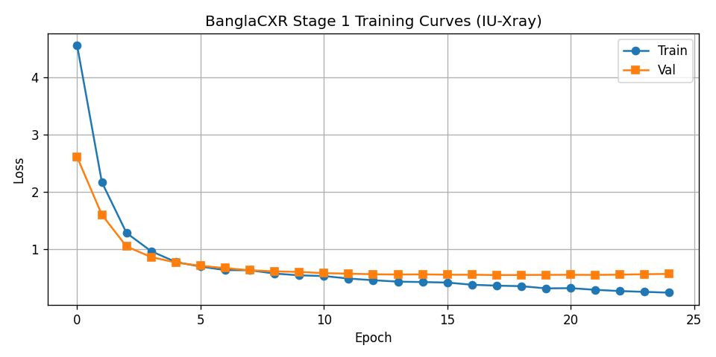

Figure 4: Training Curve

Stage 1 English NLG Results:

The AnatomyGuided model achieved the following scores on the 550-sample test set: BLEU-1 of 0.2884, BLEU-2 of 0.1664, BLEU-4 of 0.0699, ROUGE-1 of 0.4352, ROUGE-2 of 0.1604, ROUGE-L of 0.3103, METEOR of 0.2820, and chrF++ of 41.32. The FlatMLP baseline collapsed entirely, producing BLEU-1 of 0.0003, BLEU-2 of 0.0000, BLEU-4 of 0.0000, ROUGE-1 of 0.0147, ROUGE-2 of 0.0000, and ROUGE-L of 0.0146. Qualitative analysis of the baseline outputs validated the complete failure of generative model performance: each generated report was a nonsensical multilingual fragment instead of any clinical text, indicating the need for spatial visual information that is lost when using mean-pooling over 1,370 patch tokens. This is not a marginal architectural difference; it is a difference between a working system and complete failure; it makes the design of the cross-attention region query in AnatomyGuidedProjector a necessary architectural feature and not merely a better option. The achieved score of 0.4352 in ROUGE-1 is significantly comparable with the 0.3213 score obtained by XrayGPT on the MIMIC-CXR dataset (Thawakar et al., 2024), despite the differences in the datasets. The METEOR of 0.2820 is lower than ClinicalBLIP's 0.570 on IU X-ray (Ji et al., 2024) due to the former's use of two-stage LoRA approach with explicit prior clinical knowledge integration and the fact that the two datasets are different, with IU X-ray being specific to that setting and ClinicalBLIP being a general setting, while BanglaCXR is a general two-stage pipeline not optimized for just NLG score maximization. ChrF++ is 41.32 which places the model in a range typical of systems that produce fluent, but not exact, clinical text.

Clinical Entity Results:

There is marked variation in performance between pathological categories in the clinical entity evaluation. The model's performance is best on common, visually distinct findings: Pleural Effusion has an F1 score of 0.7164 and a recall score of 0.867, Pneumothorax has an F1 score of 0.7532 with a recall score of 0.904, and No Finding (normal chest) has an F1 score of 0.7962 with a recall score of 0.830. These are the categories that are most commonly found in the IU X-ray training set and the ones that are most likely to have a clear and unambiguous visual pattern in chest X-ray images. The model has a significant difficulty with less common or less obvious findings: Fracture gets an F1 of 0.0000, Nodule/Mass gets an F1 of 0.0909, and Edema gets an F1 of 0.1263. Atelectasis (F1 = 0.2500) and Consolidation (F1 = 0.2895) are also low, but do seem to be present in the training set despite the weighted sampler, and they are also quite subtle from a visual standpoint. The overall binary abnormality detection results are more promising: the model correctly identified 430 of the 439 truly abnormal cases in the test set, missed 9 (false negative), and created 108 false alarms (false positive) from the 111 normal cases. This yields a recall of 0.9795 and precision of 0.7993, with an F1 of 0.8802. In the clinical setting, the screening context, the higher the "recall", the more important the metric; the cost of a false negative is more significant than that of a false positive. The test distribution and model's reliable output space have a large gap between the micro-F1 (0.5897) and macro-F1 (0.3321) which is a typical sign of the dominance of common categories (No Finding, Pleural Effusion, Pneumothorax) in both.

Table 4: Baseline vs. Updated
Metric | FlatMLP (baseline) | AnatomyGuided (updated)
BLEU-1 | 0.0003 | 0.2884
BLEU-2 | 0.0000 | 0.1664
BLEU-4 | 0.0000 | 0.0699
ROUGE-1 | 0.0147 | 0.4352
ROUGE-2 | 0.0000 | 0.1604
ROUGE-L | 0.0146 | 0.3103
METEOR | not computed* | 0.2820
chrF++ | not computed* | 41.3185
Abnormality F1 | 0.0000 | 0.8802
Best validation loss | 1.5710 | 0.5516
Epoch reached / early stop | 3 / 10 | 18 / 25

Stage 2 Bangla Translation Results:

The Stage 2 evaluation against NLLB-200-translated Bangla references yields BLEU-1 of 0.2626, BLEU-2 of 0.1358, BLEU-4 of 0.0502, and chrF++ of 35.18. The slight decrease in the chrF++ value for Stage 1 English to 41.32 and Stage 2 Bangla to 35.18 is the cumulative impact of two steps that are imperfect: Step 1 is to generate the English text that diverges from the reference, and Step 2 is to translate the generated text to Bangla and the reference to Bangla, which may introduce further level of character level differences. Sample Bangla outputs from the qualitative inspection reveals that generated reports are grammatically correct Bangla which preserves the clinical structure of the English input including Findings/Impression, and correctly renders key pathological terms such as ফুসফুস পরিষ্কার (lungs are clear), প্লুরাল ইফিউশন (pleural effusion), and নিউমোথোরাক্স (pneumothorax). The major sources of error in the Bangla output are not due to wrong translation of clinical information but due to the inconsistency in the rendering of structural phrases like Findings in Bangla as ফলাফলঃ instead of ফলাফল; minor variations in normal anatomical description; and propagation of any such inaccuracy from the output of the English Stage 1 into the Bangla output. Combined, the results validate the pipeline's ability to function, the need for the AnatomyGuidedProjector, English performance in the range of similar resource-constrained systems in the literature, and the resulting readability and clinical structure of the Bangla translation pipeline, along with its reasonable lexical fidelity to a regularly generated reference.

Table 5: Stage-2
Metric | Score
BLEU-1 (Bangla) | 0.2626
BLEU-2 (Bangla) | 0.1358
BLEU-4 (Bangla) | 0.0502
chrF++ (Bangla) | 35.1756

Summary

This chapter has showed the complete implementation and evaluation of BanglaCXR in both pipeline stages and ablation baseline. The model trained successfully with the best validation loss value of 0.5516 after epoch 18, and reached BLEU-1 = 0.2884, ROUGE-1 = 0.4352, METEOR = 0.2820 and chrF++ = 41.32 on the English test reports of 550 reports, along with an abnormality detection F1 of 0.8802 and clinical micro-F1 of 0.5897 on 12 pathological labels. The cross-attention region query projector was indeed worth the effort, as the baseline based on the Flattened MLP failed to perform. ChrF++ was computed at 35.18 with clinically structured Bangla output for all 550 test cases in Stage 2 Bangla translation, for the first time providing the Bangla radiology NLG benchmark. The next chapter discusses the standards, limitations, sustainability issues and time frame that informed this research.

Table 6: Performance Comparison of Radiology Generation Models
System | BLEU-1 | ROUGE-1 / ROUGE-L | METEOR | Year
Mamdouh et al. survey - RADAR (top performer) | 0.509 | - / - | 0.450 | 2025
XrayGPT | - | 0.3213 / 0.1997 | - | 2024
ClinicalBLIP (IU X-ray) | - | - / 0.534 | 0.570 | 2024
ClinicalBLIP (MIMIC-CXR) | - | - / 0.313 | 0.365 | 2024
Beyond Images - FullFusion | 0.351 | - / 0.331 | - | 2024
BanglaCXR (this thesis) | 0.2884 | 0.4352 / 0.3103 | 0.2820 | 2026

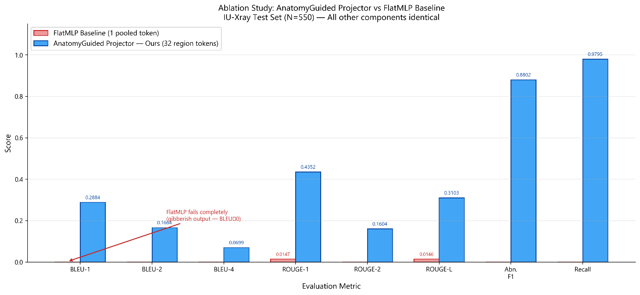

Figure 5: Ablation Study- Anatomy Guided Projector vs FlatMLP Baseline

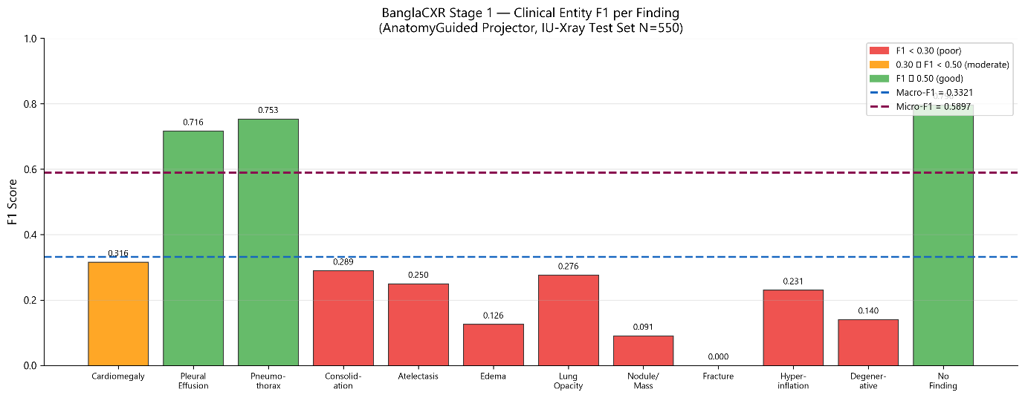

Figure 6: BanglaCXR Stage 1- Clinical Entity F1 per Finding

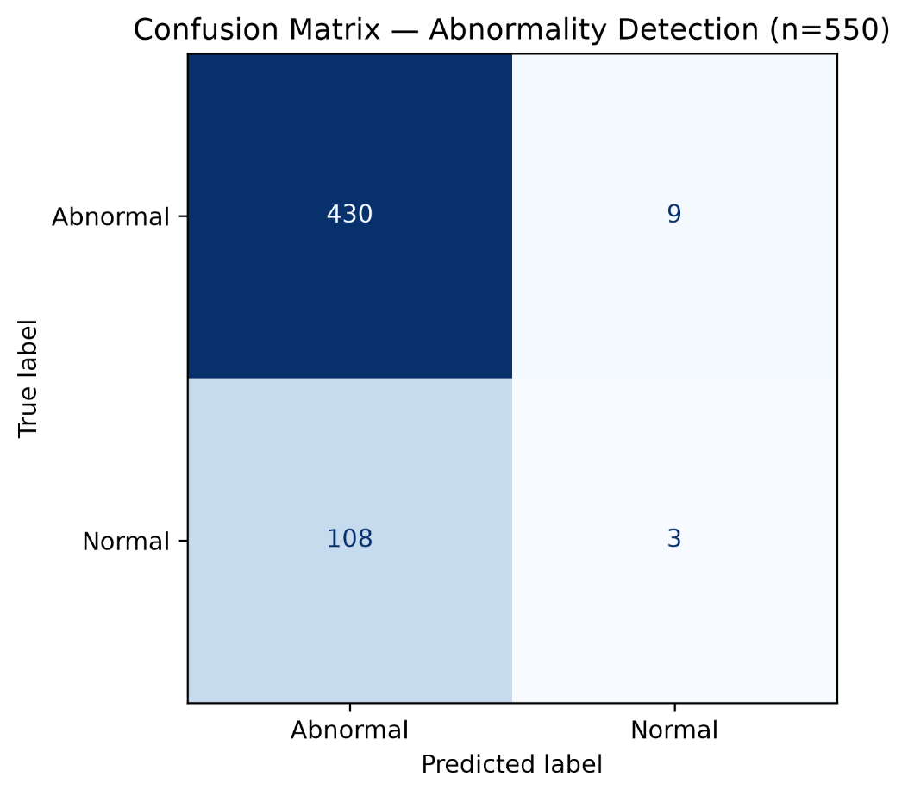

Figure 7: Confusion Matrix

Chapter 5

Standards, Constraints and Milestones

Standards and Compliance

Development of BanglaCXR followed the following known principles from the relevant standards bodies and AI ethics frameworks that are applicable to AI medical systems. A software engineering point of view, the implementation is designed and reproducible according to the IEEE guidelines for scientific software, that is, fixed random seeds (all dataset splits used with seed 42), version pinned library dependencies, notebook structure (allows the full evaluation to be independently reproduced by others) and saved model checkpoints. AI and machine learning side, the system's design follows the principles of the recent NIST AI RMF (Risk Management Framework) for trustworthy AI, such as transparency of AI system architecture and training process, measurable performance against a range of evaluation metrics, and documented failures. The training and evaluation is based on an existing public benchmark dataset (IU X-ray) instead of private clinical data, which is in line with open science practices and external validation. Meta's NLLB-200, a model designed specifically for low-resource languages, is based on the principles of responsible AI, is translated with this pipeline, and is developed by Meta AI Research. The system is not yet compliant with clinical device regulations like the FDA's Medical Device Software (SaMD) guidelines, or the EU Medical Device Regulation (MDR); it has not been clinically validated in a health care environment; not been prospectively evaluated by patients' outcomes; and has not included the clinical deployment audit trail mechanisms that are required. Any attempt to bring this to actual clinical practice would require compliance with these regulations.

Sustainability Considerations

BanglaCXR is engineered not only to be efficient, but also to be efficient as a goal, given the context of real-world deployment in resource-limited hospitals in Bangladesh. Adopted 4-bit NF4 quantization on Phi-3.5 Mini saves ~8GB of VRAM used for a full-precision inference, to ~3.15GB during the generation of a report, enabling it to be run on a single consumer-grade laptop GPU without cloud compute. Training a LoRA fine-tuned model only requires updating 1.30% of the total model parameters, significantly lowering the amount of compute needed to train the model, as well as the storage space required for the trained model, compared with fine-tuning the entire model. Distilled 600M parameter variant was chosen over the larger 1.3B and 3.3B variants for NLLB-200 to reduce the VRAM usage for stage 2, while the float16 precision brings the VRAM down to about 1.23 GB. This entire 2 stage inference pipeline is deployed on 8.5GB VRAM of test hardware, eliminating the need for cloud resources, extra GPUs or specialized accelerators. Energy-wise, the training process consumed about 25 effective epochs per laptop GPU for several hours, and the deployments would only require energy at inference time; much less demanding than training a large model. Scalability to other South Asian languages is provided by the two stage architecture: To add a new language target, just modify the NLLB-200 target language token, without retraining the core vision/language part of the system.

Societal Impact

The societal benefits of BanglaCXR are most direct when implemented in the context of health care in Bangladesh: With the extreme rarity of radiologists, large groups of the population do not receive any expert interpretation of their chest X-rays. A working reporting system with AI support in Bangla would be an effective pre-screening mechanism for district level GP's, identifying potential abnormalities and prioritising patients for referral to specialist centres, and delivering a readable initial report in Bangla. This would help minimize diagnostic delay, optimize triage and increase access to radiological skills in remote rural areas. The first release of Bangla radiology NLG benchmark has academic significance for researchers who are interested in medical AI for South Asian languages, and the proof-of-concept method of using a radiology-specialized vision encoder in conjunction with a small quantized LLM using a parameter-efficient cross-attention projector offers a template for other low-resource language deployments. But the possible downsides should be taken on as seriously, however. The system identifies reports with a clinical micro-F1 of 0.5897 on twelve pathological labels, which indicates that the current generation quality is not adequate for clinical decision making for rare findings like fracture, nodule, edema, etc. without expert supervision. If the system is deployed without this disclaimer, especially in environments with under-resourced health care practitioners who might blindly take the input from an AI without critically evaluating it, this would result in misdiagnosis and eventual patient harm. The model is also subject to demographic and imaging biases that may apply to the IU X-ray dataset which has been gathered at an American academic medical centre, which may not be representative of the distribution of pathologies, imaging equipment quality, or demographics of a Bangladeshi hospital. These risks are not against development, but against the wrong development that takes place too early without proper validation.

Ethical Considerations

There are a number of ethical considerations in this study. The first one is about bias and fairness of the training data. The IU X-ray dataset consists of data from a single academic hospital in the US, so it is specific to the quality of the equipment, patient population, clinical protocols, and reporting of that hospital. This brings in the bias at the population level: the model can be expected to perform differently with chest X-rays of Bangladeshi patients, as well as with differences in disease prevalence patterns (such as the prevalence of tuberculosis, which is significantly higher in Bangladesh than in the IU dataset) and imaging equipment properties (which can be different for Bangladeshi patients) and clinical documentation conventions; all these factors can result in a different disease burden pattern. The other issue is clinical safety. The system is designed for research purposes and for preliminary reporting only and should not substitute for experienced radiologists. All output must be considered a preliminary product and subject to expert verification and the thesis documentation and communication of any deployments should explicitly and prominently state this fact. The third concern is with regard to the Bangla translation specifically: errors in clinical translation can impact patient care due to misinterpretation of a report by a clinician based on an incorrect Bangla translation of a finding. This risk is partially reduced by the medical glossary post-processing applied in implementing, but it cannot be completely eliminated. The fourth concern is that of data privacy, where no patient identifiable data is utilized in this research, and no new patient data was gathered, but the IU X-ray dataset is a fully anonymized and de-identified public release (Demner-Fushman et al., 2016). No data were sent to external servers for model training and/or evaluation.

Security and Privacy Considerations

The privacy risk during the development and evaluation of BanglaCXR is kept to a minimum because it was done entirely on a local machine and on an already de-identified set of data from the public domain. The personally identifiable information from the IU X-ray data set has been removed and the data was acquired from the Indiana University under institutional review board guidelines. No patient information was sent to any cloud services, sent via API, or sent over networks during development or testing. The model weights saved at the checkpoints are not associated with any patient, but rather they are parameters learned from the pooled training corpus. If the system were to be used in the clinic, there would have to be some security and privacy concerns that would have to be addressed. Chest X-Ray images and reports created for patients would be considered sensitive health information under the applicable privacy laws such as Digital Security Act in Bangladesh and international laws like HIPAA and GDPR. The resulting system would need the security features of encrypted storage for input images and generated reports, user access controls (based on user roles) that would limit the viewing rights of reports to qualified clinical staff, audit logging of all model calls for accountability and a data retention policy that would determine the length of time any images and reports should be kept before they are deleted. This offline-first system, which does not need an internet connection when inferring, is a good security feature because it reduces the risk of attacks through network transmission of data.

implementation.

Design Constraints and Component Constraints

The biggest design limitation of BanglaCXR is the 8 GB VRAM limit due to the hardware available. All key decisions on architecture were forced by this constraint: use of Phi-3.5 Mini (3.8B parameters) instead of a bigger model like LLaMA-3-8B or Phi-3-medium (14B); use of the distilled NLLB-200 (600M) over the larger options; and the use of 32 region queries instead of 64 or 128 in the AnatomyGuidedProjector, which is directly responsible for the length of the visual prefix and thus the prefill memory overhead. The ability to generate reports of length up to 256 tokens (maximum length of 200) for training and generation, respectively, was a related design constraint, chosen to keep memory usage manageable, but which prevents the model from generating very long reports with extensive clinical detail. This is usually not a limiting constraint on the length of the IU X-ray reports, which are usually short, but it would be a constraint on longer reports, like those in the MIMIC-CXR style. The frozen RAD-DINO encoder cannot be further optimized without surpassing VRAM capacity, which means that the visual quality of the feature is set by the pretrained model and cannot be adjusted to different visual features of the training set. In the same way, we need to freeze the base weights of Phi-3.5 Mini, so it only has the LoRA delta weights that can be adjusted during training, and the projector can also be adjusted. This thus leaves the entire responsibility for cross-modal adaptation to the projector and to the relatively small LoRA adapters, which is feasible and yet fundamentally constrained from being as scalable as a fully fine-tuned system trained at scale with larger models and full precision weights.

Data Constraints and Computational Constraints

The main limitation of the primary data is the size and demographic characteristics of the IU X-ray database. Following cleaning and filtering, 3,666 valid pairs of image-report pairs of frontal images are available, but only 2,566 of those are used for training. This is significantly smaller than the training corpora of state-of-the-art systems: 8.5 million samples in the case of CheXagent, more than 510,000 samples for MAIRA-2, and 580,000 samples of instruction-following ones for RaDialog. It is possible to train the model using 2,566 samples, 3.8B parameters, LoRA, and 4-bit quantization, but it cannot be avoided that such a small number of samples and a limited number of parameters constrict the diversity of pathological presentations and report phrasing that the model training can learn from. There is also a significant class imbalance in the IU X-ray dataset: 439 out of 550 test samples (79.8%) have at least one abnormal present, and many classes of anomalies, like fracture and nodules, have only a few reports in total in the whole dataset. This is partially mitigated by using a weighted random sampler during training, but rare categories are still underrepresented compared to what is necessary to adequately detect at the clinical level. In Stage 2, the lack of any human-written Bangla radiology reference book makes that the evaluation references are also machine translated by NLLB-200, which creates a confound, since the score of the machine translation reflects how similar it is to another machine translated version of the same text by NLLB-200, not to another human-written version of that text by a Bangla-speaking radiologist. This will, however, need to be done via the collection and annotation of professionally written Bangla radiology reports, and that is a key priority for future work. The problem constraints are no less real. Training the AnatomyGuided model took around just a few hours for 25 epochs on the RTX 5050 Laptop GPU, which is fine for a single training session but would be expensive for larger hyperparameter optimization or cross-validation studies. The inference time per report, which includes image preprocessing, RAD-DINO encoding, projector forward pass, and autoregressive generation of up to 200 tokens, takes about 10 to 20 seconds per case on the test hardware, and is suitable for a supplementary reporting tool, but requires further optimization in the case of high throughput and deployable applications.

Budget Constraints

This is a research project that was undertaken at no cost, no money was spent. The model weights (RAD-DINO, Phi-3.5 Mini, NLLB-200) are all released as open-source under open source licenses on HuggingFace. This IU X-ray dataset is openly available on the Open-i platform of the National Library of Medicine. All software libraries used are open source software which are freely licensed. All training was done on the personal hardware - RTX 5050 Laptop GPU - without incurring cloud compute costs. None of the proprietary annotation tools, clinical databases or subscription based APIs were used at any stage. This zero-budget constraint was not simply a constraint, but a design feature as well, as one of the motivations of the research is to illustrate that a working Bangla radiology AI pipeline can be built without institutional compute infrastructure to make the methodology accessible for researchers in Bangladesh and other low-income settings with similar compute resource constraints. The major cost would be to extend the research towards clinical validation, which would involve professionally written Bangla radiology reports being annotated by trained radiologists, and paying them for their efforts.

Task Breakdown and Project Timeline

In this lesson, students examine the process of task breakdown and the project timeline. The research was conducted in six consecutive steps, which took about five months. This first phase (lasting about three weeks) was dedicated to the identification of the problem and the literature survey, which included a systematic review of 30 papers from different domains: radiology report generation, Bangla NLP, multilingual clinical NLP, and AI in low-resource healthcare, and eventually, a well-defined research gap and research goals. The second phase lasted 2 weeks and involved downloading the IU X-ray dataset, writing the filter and merge pipeline, making the train/validation/test splits and checking the availability of the images and completeness of the reports. The third phase, which lasted around four weeks, focused on the design of the AnatomyGuidedProjector, the embedding of RAD-DINO and Phi-3.5 Mini, the prompt template design, the design of the weighted sampler, and training loop implementation with gradient accumulation and learning rate scheduling. The fourth phase lasted about three weeks and included model training, checkpoint management, and tracking of training dynamics, which involved addressing some instability challenges that were experienced in the initial training runs. The fifth phase lasted two weeks and involved implementation of evaluation and execution of the ablation study, including coding all the NLG and clinical metrics, running the two models (AnatomyGuided and FlatMLP) over all 550 test cases, and implementing the Stage 2 translation pipeline and its evaluation. The sixth and final phase was a three-week period for the analysis of the results, figure generation and thesis writing. A breakdown of the task within these phases can be explained as follows. Literature review was carried out by reading and systematically annotating 30 papers, developing the problem statement and formulating the objectives. For the preparation of data sets, utilities for writing the data to the file system were written and the abnormality pattern detector for the weighted sampler was implemented, and the integrity of the 3,666 image-report pairs was verified. The implementation of the architecture comprised the creation of the AnatomyGuidedProjector class, BanglaCXRStage1 model class, the CXRDataset class and finally the generation function. Training consisted of multiple sessions, saving checkpoints, keeping an eye on VRAM, and figuring out what went wrong in preliminary training sessions before the final configuration stabilized to produce the loss. Evaluation was done by applying seven NLG metrics, twelve-label clinical entity extraction, the complete ablation comparison, and the Bangla Stage 2 evaluation. One of the tasks of documentation was to prepare the entire thesis text, figures and references.

Milestones and Deliverables

The project is broken down into 5 key milestones. The first milestone is the literature review and problem specification, which is accomplished when the 30 annotated paper reviews are completed and the problem statement and objective set is written. The next milestone is dataset readiness, which means the availability of 3,666 image-report pairs with IU X-rays that have been cleaned and split, file integrity checked and the weighted random sampler is working. The third milestone is the trained AnatomyGuided Stage 1 model, with the best checkpoint saved from epoch 18 with a validation loss of 0.5516 and 550 English test reports generated and saved to stage2_english_reports.json. The fourth milestone is the ablation study and Stage 2 evaluation, which includes the final comparison table (AnatomyGuided versus FlatMLP) for all metrics and the Bangla evaluation results are recorded in stage2_bangla_full.json. The sixth and last milestone is the finished thesis with all six chapters, all references listed in the APA format and the six visualization figures created during the ablation phase. For every milestone there is a clear, tangible, and verifiable deliverable, such as a document or a saved file or a set of measurable numerical results, that can be measured, and that the research can be fully reproduced from the available artifacts.

Gantt Chart

The Gantt chart for this project illustrates the six project phases, relating them to a 5-month time period from the initiation of the project until thesis submission. The phases are represented by horizontal bars across the weeks of their allocated time and the dependency between the phases is reflected in the sequential arrangement of the bars from literature review to dataset preparation, through architecture design, training, evaluation and documentation. Some phases occurred in parallel, such as the early training phase and the architecture refinements, where documentation and analysis started concurrently with the initial evaluation runs, rather than waiting for all results to be consolidated, and documentation and problem statement formation started during the initial literature review phase, which continued while some of the architecture refinements were performed. Training and evaluation is a critical path, where the 550 English test reports, and the Ablation comparison was a prerequisite for all the following stage 2 evaluation and for the results discussion in the thesis. Although not an idealized plan, the Gantt chart is presented as Figure 7 in the appendix, and shows the actual timeline that was followed, rather than what may have been ideal.

Table 7: Project-Thesis Deliverables
Project Tasks | Schedule Data | Execution Data | Duration (Day)
1. Problem Selection and Literature Review | 1 Feb (2026) | 16 Feb (2026) | 16
2. Dataset Collection | 17 Feb (2026) | 21 Feb (2026) | 5
3. Data Preprocessing | 22 Feb (2026) | 28 Feb (2026) | 7
4. Architecture Design | 1 Mar (2026) | 16 Mar (2026) | 16
5. Translation Pipeline | 17 Mar (2026) | 25 Mar (2026) | 9
6. Model Training | 26 Mar (2026) | 16 Apr (2026) | 22
7. Evaluation Studies | 16 Apr (2026) | 6 May (2026) | 21
8. Result Analysis | 7 May (2026) | 14 May (2026) | 7
9. Thesis Documentation | 15 May (2026) | 31 May (2026) | 17

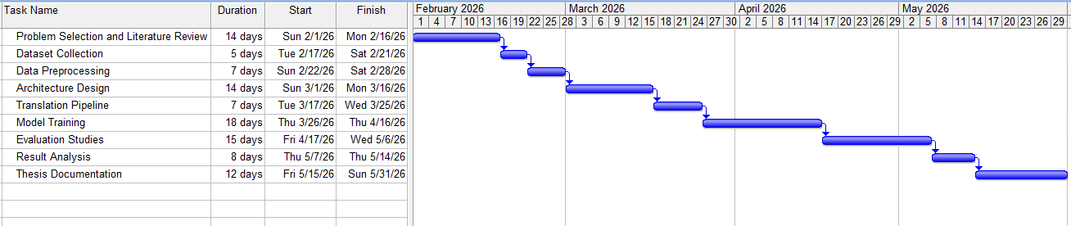

Figure 8: Gantt Chart

Summary

In this chapter, the entire spectrum of standards, constraints, and project management issues that affected the way this research was conducted have been described. While BanglaCXR supports open science and reproducible AI practices, it currently lacks clinical regulatory standards, but these standards are a deliberate scope decision and not overlooked. The consistent design choices made in the system are based on a set of computational sustainability choices due to the 8.5GB VRAM constraint and these choices together result in a system that is deployable on consumer hardware, which is a contribution to equitable use of AI in low resource settings. Data limitations, in particular the size and size of the demographic of IU X-ray training set, and lack of human annotated Bangla references, are the most important limitations on the strength of the current results and thus the most important directions of future work. The project was carried out in six successive stages, which were completed in about 5 months, and the project was able to deliver the six major milestones and all the experimental artifacts it had produced were reproducible. The final chapter brings the research findings together, restates the contributions and provides specific direction for further work on this subject.

Chapter 6

Conclusion

Summary of the Study

The aim of this thesis was to fill in this important, yet practically needed void: a completely missing resource of AI-assisted reporting of chest X-rays in Bangla, the native language of more than 170 million people, and where a radiologist is available for less than one person in every 200,000 people. We have designed, implemented and evaluated BanglaCXR, a two stage pipeline of vision-to-language and language-to-vision. The first stage is made up of a frozen RAD-DINO vision encoder, a novel cross-attention module named AnatomyGuidedProjector and a LoRA fine-tuned Phi-3.5 Mini language model which outputs structured English radiology reports from chest X-ray images. In the second stage, the English reports are translated into Bangla using NLLB-200. The system has been trained and tested on the Indiana University Chest X-ray database, with 2566 training samples, 550 validation samples and 550 test samples being all performed on consumer-grade hardware with 8.5GB VRAM. Stage 1 obtained BLEU-1 score of 0.2884, ROUGE-1 score of 0.4352, METEOR score of 0.2820 and chrF++ score of 41.32 in twelve pathological categories, whereas the score of abnormality detection F1 was 0.8802, and clinical micro-F1 was 0.5897. At stage 2, Bangla reports were generated by chrF++ with the score of 35.18 on NLLB-200-translated reference texts, producing reasonably good reports and clinically organized output. An ablation study confirmed that the AnatomyGuidedProjector is necessary for the model, with a baseline model consisting of a FlatMLP mean-pooling architecture failing to collapse the generation for all metrics.

Key Contributions

The study has four specific contributions. The first is BanglaCXR itself, the first end-to-end pipeline evaluated with over 550 test cases, which fully documented for re-implementability, and has been shown to generate structured chest X-ray radiology reports in Bangla. The second is the AnatomyGuidedProjector, a cross-attention module comprising of 32 learnable region queries, which effectively reduces the number of patch tokens in RAD-DINO (1,370) to region-aware embeddings, conditions the language model, with the ablation study showing that this is architecturally crucial, as the FlatMLP alternative fails to boost results substantially (0.0003 BLEU-1 vs. 0.2884). The third is the first structured Bangla radiology NLG benchmark with 550 paired English-Bangla evaluated report samples that can be used by future researchers to evaluate and compare Bangla medical text generation models. The fourth is the clinical entity evaluation framework across 12 pathological categories, which serves as a diagnostically-informed supplement to NLG metrics, and gives a more actionable view of clinical deployment readiness than the NLG metrics do individually.

Limitations of the Study
There were some restrictions in the present study. The training data is the most significant: 2,566 samples from one American academic hospital is a narrowly demographically and small body of material to train a clinical generation model for Bangladeshi patients. The IU X-ray data are not representative of the disease burden, equipment, or clinical reporting approaches of Bangladeshi hospitals, and the model's performance in true in-distribution Bangladesh chest X-rays remains unclear. The results of rare pathological categories such as fractures, nodules, edema, and atelectasis are below 0.25 in both English as well as Bangla, meaning that the model performance is not reliable enough to detect these pathological findings yet. A methodological weakness of the Stage 2 evaluation is that there are no human-written Bangla references to compare against, so the references used in the evaluation are also created by NLLB-200, which means that the chrF++ score reflects the consistency between two machine-generated translations instead of fidelity to the expert human output. Whilst the FlatMLP ablation is an important control, it does not represent a comparison with other published systems on the same data set and hardware constraints, so it is not possible to contextualise BanglaCXR's performance in detail in relation to the literature. Lastly, there is absolutely no clinical validation of the system: no radiologist has examined the reports provided by the system, no patient outcome data has been gathered and no assessment of clinical “usefulness” has been performed.

Future Work
The biggest extension of this work is the collection and annotation of a Bangla-medium radiology report corpus authored by qualified Bangladeshi radiologists to solve the training data limitation and the evaluation reference problem at once. A collection of 500 – 1000 professionally written Bangla reports, even at this magnitude, would contribute significantly to the validity of the Stage 2 evaluation and can be used as a fine-tuning goal for an NLLB-200 adapted translation model. The second direction is expanding the vision-language model training set to a larger-sized dataset like MIMIC-CXR, possibly with a cross-dataset transfer strategy by pretraining the model on MIMIC-CXR and fine-tuning it with IU X-ray to ensure a more comprehensive exposure to the vast range of pathological images. Third, the clinical entity evaluation results indicate that more substantial training sets, broader training sets, or some form of a structured prior clinical knowledge (like ClinicalBLIP (Ji et al., 2024) would be needed to improve performance on rare findings. Fourth, swapping the NLLB-200 translation model with a fine-tuned domain-adapted clinical translation model for the English-to-Bangla language pair, as shown by Han et al. (2024) for other clinical language pairs, would likely result in significantly improved output quality for Bangla. Lastly, a formal clinical evaluation study of Bangladeshi radiologists who would read the system-generated reports in comparison to reference reports without knowing which was generated by the system would be necessary to determine if the system would have real world clinical utility and what deployment-protective measures are required for any actual use.

References

- Adhikari, S., Ahmed, I., Bajracharya, D., Khanal, B., et al. (2025). Transforming healthcare through just, equitable and quality driven artificial intelligence solutions in South Asia. npj Digital Medicine.
- Chen, Z., Varma, M., et al. (2024). A vision-language foundation model to enhance efficiency of chest X-ray interpretation. arXiv:2401.12208.
- Bannur, S., Bouzid, K., Castro, D. C., et al. (2024). MAIRA-2: Grounded radiology report generation. arXiv:2406.04449.
- Pellegrini, C., Özsoy, E., Busam, B., Wiestler, B., Navab, N., & Keicher, M. (2025). RaDialog: A large vision-language model for radiology report generation and conversational assistance. MIDL 2025, Technical University of Munich.
- Thawakar, O., Shaker, A., Mullappilly, S. S., Cholakkal, H., Anwer, R. M., Khan, S., Laaksonen, J., & Khan, F. S. (2024). XrayGPT: Chest radiographs summarization using large medical vision-language models. Proceedings of the 23rd Workshop on Biomedical Language Processing, ACL 2024.
- Wu, J., Kim, Y., Shi, D., Cliffton, D., Liu, F., & Wu, H. (2024). SLaVA-CXR: Small language and vision assistant for chest X-ray report automation. arXiv.
- Salhi, M., & Akhloufi, M. A. (2026). Recent progress in deep learning for chest X-ray report generation. BioMedInformatics, 6(1)
- Tran, C., Pal, B., Stirrat, T., Shi, V., & Umair, M. (2026). Recent advances in artificial intelligence for radiology report generation: A brief review. BJR Artificial Intelligence, 3(1).
- Bhattacharjee, A., Hasan, T., Ahmad, W. U., & Shahriyar, R. (2022). BanglaBERT: Language model pretraining and benchmarks for low-resource language understanding evaluation in Bangla. Findings of ACL: NAACL 2022, 1318–1327.
- Bhattacharjee, A., Hasan, T., Ahmad, W. U., & Shahriyar, R. (2023). BanglaNLG and BanglaT5: Benchmarks and resources for evaluating low-resource natural language generation in Bangla. Findings of EACL 2023.
- Raihan, N., & Zampieri, M. (2025). TigerLLM: A family of Bangla large language models. Proceedings of ACL 2025, Volume 2: Short Papers.
- Kabir, M., Islam, M. S., Laskar, M. T. R., Nayeem, M. T., Bari, M. S., & Hoque, E. (2024). BenLLM-Eval: A comprehensive evaluation into the potentials and pitfalls of large language models on Bengali NLP.
- Salmè, M., Sicilia, R., Soda, P., & Guarrasi, V. (2025). Evaluating vision language model adaptations for radiology report generation in low-resource languages. arXiv.
- Hussain, S. A., Bresnahan, M., & Zhuang, J. (2025). Can artificial intelligence revolutionize healthcare in the Global South? A scoping review of opportunities and challenges. DIGITAL HEALTH, 11.
- Al-Ganad, A., et al. (2026). Deploying medical AI in low-resource settings: A scoping review of challenges and strategies. Frontiers in Digital Health.
- Wibowo, M. F., Pyle, A., Lim, E., Ohde, J. W., Liu, N., & Karlström, J. (2025). Insights into the current and future state of AI adoption within health systems in Southeast Asia: Cross-sectional qualitative study. Journal of Medical Internet Research, 27, e71591.
- Tanno, R., Barrett, D. G. T., et al. (2025). Collaboration between clinicians and vision-language models in radiology report generation. Nature Medicine, 31.
- Sîrbu, I., Sîrbu, I.-R., Bogojeska, J., & Rebedea, T. (2025). GIT-CXR: End-to-end transformer for chest X-ray report generation. arXiv:2501.02598.
- Ji, J., Hou, Y., Chen, X., Pan, Y., & Xiang, Y. (2024). Vision-language model for generating textual descriptions from clinical images: Model development and validation study. JMIR Formative Research.
- Hartsock, I., & Rasool, G. (2024). Vision-language models for medical report generation and visual question answering: A review. Frontiers in Artificial Intelligence.
- Mamdouh, D., Attia, M., Osama, M., et al. (2025). Advancements in radiology report generation: A comprehensive analysis. Bioengineering, 12(693).
- Lian, C., Zhou, H.-Y., Yu, Y., & Wang, L. (2024). Less could be better: Parameter-efficient fine-tuning advances medical vision foundation models. Under review, MIDL 2024.
- Aksoy, N., Sharoff, S., Baser, S., Ravikumar, N., & Frangi, A. F. (2024). Beyond images: An integrative multi-modal approach to chest X-ray report generation. Frontiers in Radiology.
- Abrar, A., Tabassum, F., & Ahmed, S. (2024). Performance evaluation of large language models in Bangla consumer health query summarization. Proceedings of the 2024 International Conference on Computer and Information Technology (ICCIT), Cox's Bazar, Bangladesh.
- Aurpa, T. T., Akter, F., et al. (2025). Bangla MedER: Multi-BERT ensemble approach for the recognition of Bangla medical entity. arXiv:2512.17769.
- Han, L., Gladkoff, S., Erofeev, G., Sorokina, I., Galiano, B., & Nenadic, G. (2024). Neural machine translation of clinical text: An empirical investigation into multilingual pre-trained language models and transfer-learning. Frontiers in Digital Health.
- Luo, Y., Zhou, L., Jhingoer, A., Vliegenthart-Jongbloed, K., Jordans, C., Werkhoven, B., Seinen, T., van Mulligen, E., Rokx, C., & Li, Y. (2024). Multilingual BERT language model for medical tasks: Evaluation on domain-specific adaptation and cross-linguality. Erasmus University Medical Center.
- Gangavarapu, A. (2024). Introducing L2M3: A multilingual medical large language model to advance health equity in low-resource regions. arXiv:2404.08705.
- Pérez-García, F., Sharma, H., Bond-Taylor, S., et al. (2024). RAD-DINO: Exploring scalable medical image encoders beyond text supervision. arXiv:2401.10815.
- Demner-Fushman, D., Kohli, M. D., Rosenman, M. B., Shooshan, S. E., Rodriguez, L., Antani, S., Thoma, G. R., & McDonald, C. J. (2016). Preparing a collection of radiology examinations for distribution and retrieval. Journal of the American Medical Informatics Association, 23(2), 304–310.

Appendix

- https://github.com/ahasan-ullah/Thesis

